“Flight Academy Admission Portal”
A Project Report Submitted in the partial fulfillment of the requirements for the award of the degree of

BACHELOR OF TECHNOLOGY
In
DEPARTMENT OF ELECTRONICS AND COMMUNICATION ENGINNERING
&
DEPARTMENT OF COMPUTER SCIENCE AND INFORMATION TECHNOLOGY By

M. Surarichita Laxmi (2520040101)
I. Joshitha (2520040062)

Under the Esteemed Guidance of
- Anusha
Assistant Professor

Department of Computer Science and Engineering


K L (Deemed to be) University DEPARTMENT OF COMPUTER SCIENCE ENGINEERING
&

DEPARTMENT OF COMPUTER SCIENCE AND INFORMATION TECHNOL


Declaration
The Project Report entitled “Design and Development of an Integrated Tourism Platform for Flights, Trains, Hotels, and Hidden Destinations” is a record of Bonafide work of INTURI JOSHITHA- 2520040062, MANDAVA SURARICHITA LAXMI- 2520040101 submitted in partial fulfillment for the award of B. Tech in Computer Science and Engineering (or) Computer Science and Information Technology to the K L University. The results embodied in this report have not been copied from any other departments/University/Institute.
M. SURARICHITA LAXMI– 2520040101
I. JOSHITHA – 2520040062

K L (Deemed to be) University
DEPARTMENT OF ELECTRONICS AND COMMUNICATION ENGINNERING
&
DEPARTMENT OF COMPUTER SCIENCE AND INFORMATION TECHNOLOGY


CERTIFICATE
This is certify that the mini project based report entitled“Design and Development of an Integrated Tourism Platform for Flights, Trains, Hotels, and Hidden Destinations” is a
bonafide work done and submitted by INTURI JOSHITHA- 2520040062, MANDAVA SURARICHITA LAXMI- 2520040101 in partial fulfillment of the requirements for the award of the degree of BACHELOR OF TECHNOLOGY in Department of Computer Science Engineering, K L (Deemed to be University), during the academic year 2024-2025.
Signature of the Guide
Signature of the Course Coordinator Signature of the HOD

ACKNOWLEDGEMENT
The success in this project would not have been possible but for the timely help and guidance rendered by many people. Our wish to express my sincere thanks to all those who has assisted us in one way or the other for the completion of my project.
Our greatest appreciation to my Course Coordinator Dr. K Madhavi, and my guide K. Anusha, Department of Computer Science which cannot be expressed in words for his/her tremendous support, encouragement and guidance for this project.
We express our gratitude to Dr. P Venkateshwara Roa (CSE)/Dr. Kaja Shareef (CSIT), Head of the Department for Computer Science Engineering/ Department for Computer Science and Information Technology for providing us with adequate facilities, ways and means by which we are able to complete this project-based Lab.
We thank all the members of teaching and non-teaching staff members, and also who have assisted me directly or indirectly for successful completion of this project. Finally, I sincerely thank my parents, friends and classmates for their kind help and cooperation during my work.
M. SURARICHITA LAXMI– 2520040101
I. JOSHITHA – 2520040062

Abstract

The Flight Academy Admission Portal is a web-based application developed to simplify and modernize the admission process for aviation training institutes. Traditional admission procedures often involve manual paperwork, lengthy verification processes, and difficulties in tracking application status. This project provides a centralized digital platform where students can complete every stage of the admission process online, making it faster, more efficient, and transparent. The portal is designed using React.js, HTML5, CSS3, and JavaScript, providing a responsive and user-friendly interface that enhances the overall user experience.

The system offers a step-by-step admission workflow, including eligibility verification, student profile creation, online application submission, document upload, entrance test, score generation, application status tracking, and digital offer letter generation. Each module is integrated with a progress tracker to guide applicants through the admission process in a structured manner. Form validation, state management, and interactive components ensure accurate data collection and improve usability. The portal also includes an FAQ section to assist applicants and reduce common queries during the admission process.

The proposed system significantly reduces manual effort, minimizes paperwork, and improves communication between applicants and the academy. It provides secure handling of student information while enabling faster processing of applications and better admission management. The project demonstrates the effective use of modern web technologies to automate institutional processes and can be further enhanced with database integration, secure authentication, online payment facilities, email notifications, AI-based document verification, and real-time administrative monitoring, making it suitable for deployment in modern flight training institutions.

Index
S.  No. | Chapters | Topics | Page.no
 |  | Acknowledgement
 |  | Abstract
1 | Introduction | 1.1 Background of the project  1.2 Problem statement  1.3 Scope of the project  1.4 Objective(s)  1.5 Importance of the application  1.6 Target users/audience | 5-15
2 | System Requirements | 2.1 Hardware requirements  2.2 Software requirements  2.3 Development tools and frameworks | 16-21
3 | Technology Stack | 3.1 Front-end (e.g., React.js, Angular, HTML/CSS)  3.2 Back-end (e.g., Node.js, Django, Spring Boot)  3.3 Database (e.g., MongoDB, MySQL, PostgreSQL)  3.4 Version Control (e.g., Git, GitHub)  3.5 APIs or External services (e.g., Firebase, Stripe) | 22-32
4 | System Architecture | 4.1 High-level architecture diagram  4.2 Description of each layer (frontend, backend, database)  4.3 Deployment architecture (e.g., cloud, local, CI/CD pipelines) | 33-36
5 | Design | 5.2 ER Diagram / Database schema | 37
6 | Implementation | 6.1 Module-wise implementation  6.2 Front-end logic (UI rendering, state management)  6.3 API integration  6.4 Authentication & Authorization | 38-47
7 | Features | 7.1 List of main features  7.2 How each feature works (user perspective + technical description) | 48-55
8 | Testing | 8.1 Postman testing (frontend/backend)  8.2 Integration testing  8.3 Tools used for testing  8.4 Test cases and results | 56-64
9 | Deployment | 9.1 Steps to deploy  9.2 Environment configuration  9.3 Hosting of frontend and backend | 65-73
10 | Challenges &  Limitations | 10.1 Issues faced during development  10.2 Solutions applied  10.3 Current limitations or known bugs | 74-82
11 | Future Enhancements | 11.1 Planned features  11.2 Possible integrations or optimizations | 83-88
12 | Conclusion | 12.1 Summary of the project  12.2 What was achieved  12.3 Skills learned during development | 89-97
13 | References | - Books, tutorials, APIs, documentation sites used | 98-99

14 | Appendices | - Screenshots of the app  - Sample code snippets  - Installation/setup instructions  - User manual or guide  -Geo Tag photos with guide  -Review forms with guide signatures | 100-105

CHAPTER -1 INTRODUCTION

1.1 Background of the Project

The aviation industry has experienced remarkable growth over the past decade, leading to an increased demand for qualified pilots, cabin crew members, and aviation professionals. As a result, flight academies receive a large number of admission applications every academic year. Traditionally, these admission procedures involve paper-based application forms, manual verification of documents, in-person interactions, and lengthy communication between applicants and the academy. Such conventional methods are time-consuming, prone to human error, and often result in delays in processing applications. Applicants also face difficulties in tracking the status of their applications, leading to uncertainty and inconvenience.

With the rapid advancement of information and communication technologies, educational institutions have increasingly adopted web-based systems to automate administrative processes. Online admission portals have become an effective solution for managing student registrations, application submissions, document verification, and communication. However, many existing admission systems are either partially automated or lack essential features such as real-time status tracking, integrated eligibility verification, secure document submission, and digital admission confirmation. This creates the need for a comprehensive admission management system specifically designed to meet the requirements of aviation training institutes.

The Flight Academy Admission Portal has been developed to provide a complete digital solution for the admission process of a flight academy. The portal enables students to complete every stage of admission through a single web application, eliminating the need for multiple manual procedures. The system guides applicants through a structured workflow that includes eligibility verification, student profile creation, admission application submission, document upload, online entrance test, score generation, application status tracking, and digital offer letter generation. This organized approach ensures that applicants can complete the admission process conveniently while reducing the workload of administrative staff.

The project has been developed using modern web technologies such as React.js, HTML5, CSS3, and JavaScript, which provide a responsive and interactive user interface. React's component-based architecture improves code reusability, simplifies maintenance, and enables efficient state management using React Hooks such as useState and useEffect. CSS3 has been used to create an attractive, responsive, and user-friendly interface that adapts to different screen sizes, while JavaScript provides the dynamic functionality required for form validation, navigation, quiz evaluation, and application tracking.

One of the major strengths of the proposed system is its step-by-step admission workflow. Instead of presenting all forms simultaneously, the portal allows applicants to proceed only after successfully completing the previous stage. This includes eligibility verification based on age, profile creation, application submission, document upload, entrance test, score evaluation, status tracking, and offer letter generation. A visual progress tracker helps users understand their current stage in the admission process, improving usability and minimizing confusion.

The portal also incorporates an online aviation entrance test consisting of multiple-choice questions related to basic aviation knowledge. The system automatically evaluates the responses, calculates the score, and determines whether the applicant qualifies for further processing. Applicants can immediately view their scores, review correct answers, and check their admission status. Based on the evaluation results, the system generates an admission decision and provides a digital offer letter for successful candidates. This automation significantly reduces manual evaluation effort while ensuring transparency in the selection process.

From an engineering perspective, the project demonstrates the practical application of several important concepts in software development, including:

Web Application Development: Designing responsive user interfaces using React.js, HTML5, CSS3, and JavaScript.

State Management: Managing application data efficiently using React Hooks such as useState and useEffect.

Form Validation: Ensuring accurate and complete user input before proceeding to the next stage.

User Interface Design: Creating an intuitive, responsive, and accessible interface for applicants.

Software Engineering Principles: Developing a modular, scalable, and maintainable application using reusable components and structured workflows.

The proposed system provides significant advantages for both applicants and flight academy administrators. Students benefit from a faster, transparent, and user-friendly admission process that can be completed from any location using an internet-enabled device. Administrators benefit from reduced paperwork, improved record management, simplified document verification, and better monitoring of admission activities. The portal also minimizes human errors, reduces processing time, and improves communication between applicants and the academy.

Furthermore, the project aligns with the growing trend of digital transformation in educational institutions and supports paperless administration. By replacing manual admission procedures with an integrated web-based solution, the Flight Academy Admission Portal contributes to efficient institutional management while enhancing the overall applicant experience. Future enhancements such as database integration, secure authentication, payment gateway support, email notifications, AI-based document verification, and mobile application support can further improve the capabilities of the system and make it suitable for deployment in real-world aviation training institutes.

In summary, the background of this project is based on three key observations:

Traditional flight academy admission procedures are manual, time-consuming, and inefficient.

Modern web technologies enable the development of secure, interactive, and fully automated admission systems.

Educational institutions require integrated digital solutions that improve transparency, efficiency, accessibility, and user experience.

By addressing these challenges, the Flight Academy Admission Portal provides a reliable, scalable, and user-friendly admission management system that simplifies the entire admission process while demonstrating the effective application of modern web development technologies.

1.2 Problem Statement
The admission process followed by many flight academies is still largely dependent on manual and paper-based procedures. Students are required to fill out physical application forms, submit documents in person, and frequently visit the academy to complete different stages of the admission process. These traditional methods consume considerable time, increase administrative workload, and are prone to human errors. Applicants also face delays in receiving updates regarding their application status, making the admission process slow, inconvenient, and less transparent.
Although many educational institutions have introduced online admission systems, most existing solutions do not provide a complete end-to-end admission workflow. Applicants often have to use different platforms for registration, document submission, entrance examinations, fee payment, and status tracking. The absence of an integrated system creates unnecessary complexity, requiring students to repeatedly enter the same information and making it difficult for administrators to manage applicant records efficiently. Furthermore, manual document verification and paper-based record maintenance increase the chances of misplaced documents, data inconsistencies, and processing delays.
Another major challenge is the lack of real-time communication and automated admission tracking. In conventional systems, applicants have limited visibility into the progress of their applications and must rely on phone calls, emails, or physical visits to obtain updates. Similarly, entrance test evaluation and admission decisions are often performed manually, increasing processing time and reducing operational efficiency. Existing systems also provide limited guidance to applicants during the admission process, resulting in incomplete applications and frequent errors.
From a technical perspective, many admission portals lack modern web-based features such as responsive user interfaces, structured workflows, automatic eligibility verification, secure document management, and interactive progress tracking. These limitations affect the overall user experience and make the admission process difficult to navigate, especially for first-time applicants. Educational institutions require an admission system that is reliable, scalable, easy to maintain, and capable of handling multiple applicants simultaneously while ensuring data accuracy and security.
The Flight Academy Admission Portal addresses these challenges by providing a comprehensive web-based admission management system. The portal integrates all admission activities into a single platform, allowing applicants to complete eligibility verification, profile creation, application submission, document upload, entrance test, score generation, application status tracking, and digital offer letter generation through one seamless workflow. The system uses React.js, JavaScript, HTML5, and CSS3 to provide a responsive and user-friendly interface with efficient state management and real-time interaction.
The proposed system aims to solve the identified problems by achieving the following objectives:
- Eliminate manual paperwork by digitizing the complete admission process.
- Provide a unified admission platform that integrates registration, application, document upload, entrance test, and admission confirmation.
- Reduce processing time through automated eligibility verification, quiz evaluation, and status tracking.
- Improve transparency by allowing applicants to monitor their admission progress in real time.
- Enhance data accuracy and security through structured digital forms and centralized information management.
- Improve user experience by providing a responsive, step-by-step guided admission workflow.
- Reduce administrative workload by automating repetitive admission tasks and maintaining digital student records.
In summary, the problem addressed by this project is the absence of a complete, secure, and user-friendly digital admission system for flight academies. The proposed Flight Academy Admission Portal bridges this gap by providing an integrated web application that simplifies the admission process for students while enabling efficient application management for administrators. By replacing manual procedures with an automated workflow, the system improves efficiency, transparency, accuracy, and overall user satisfaction, making it suitable for modern aviation training institutions.

1.3 Scope of the Project
The scope of the Flight Academy Admission Portal extends across multiple aspects of the admission management process, including student registration, eligibility verification, application management, document submission, entrance examination, admission status tracking, and digital offer letter generation. The primary objective of the project is to provide a comprehensive web-based solution that automates the complete admission workflow for flight training institutes. By integrating all admission activities into a single platform, the system minimizes manual intervention, reduces paperwork, and improves the overall efficiency of the admission process.
The technical scope of the project involves the development of a responsive web application using React.js, HTML5, CSS3, and JavaScript. The portal is designed with a component-based architecture that ensures modularity, scalability, and easy maintenance. React Hooks such as useState and useEffect are used for efficient state management and dynamic rendering of user interfaces. The application follows responsive design principles, allowing users to access the portal seamlessly from desktops, laptops, tablets, and smartphones. The modular architecture also enables future integration with backend databases, cloud services, and authentication systems without requiring major modifications to the existing codebase.
The functional scope covers the complete digital admission workflow. Applicants can verify their eligibility, create a personal profile, complete the admission application form, upload required documents, participate in an online aviation entrance test, view their examination score, track the progress of their application, and receive a digital offer letter upon successful selection. The system also includes a visual progress tracker that guides applicants through each stage of the admission process, ensuring clarity and ease of navigation.
The project further focuses on providing a user-friendly interface that simplifies the admission process for students with varying levels of technical knowledge. Interactive forms, input validation, responsive navigation, and clear instructions reduce user errors and improve the overall user experience. The portal also includes an FAQ section that answers common admission-related questions, minimizing the need for direct administrative support and improving communication between applicants and the institution.
From an administrative perspective, the portal provides a structured framework for managing applicant information in a digital environment. The system is designed to support future administrative modules where authorized staff can review applications, verify uploaded documents, monitor entrance test performance, approve or reject applications, and generate admission reports. Digital record management reduces storage requirements, improves data retrieval, and minimizes the chances of document loss or duplication.
The project also emphasizes scalability and future expansion. Although the current implementation primarily focuses on the front-end admission workflow, the architecture supports integration with technologies such as Node.js, Express.js, MongoDB, or MySQL for permanent data storage. Additional features including secure user authentication, online fee payment, email and SMS notifications, AI-based document verification, cloud storage, and mobile application support can be incorporated in future versions without affecting the existing structure.
From an educational perspective, the project demonstrates the practical application of modern web development concepts, including responsive user interface design, component-based development, state management, form validation, workflow automation, and software engineering principles. The portal serves as an effective learning platform for implementing real-world admission management systems while addressing practical challenges faced by educational institutions.
The current version of the project has certain limitations. It primarily demonstrates the admission workflow using front-end technologies and does not include a live backend server, database connectivity, payment gateway integration, or role-based authentication. Document uploads, application records, and admission status are managed within the application's state rather than being permanently stored in a database. These limitations provide opportunities for future enhancement and deployment in real-world environments.
The scope of the project can be summarized as follows:
- Development of a web-based Flight Academy Admission Portal using React.js.
- Implementation of eligibility verification and student profile management.
- Online admission application and digital document upload.
- Integrated aviation entrance test with automatic score generation.
- Application status tracking with a step-by-step progress indicator.
- Digital offer letter generation for selected applicants.
- Responsive and user-friendly interface compatible with multiple devices.
- Modular architecture supporting future database integration, authentication, online payments, and administrative management.
In conclusion, the Flight Academy Admission Portal provides a complete digital framework for managing the admission process of aviation training institutes. The project combines modern web technologies with a structured admission workflow to improve efficiency, transparency, and user experience. Its scalable architecture and modular design make it suitable for future enhancements, enabling the system to evolve into a fully functional admission management solution for real-world flight academies.

1.4 Objectives of the Project
The primary objective of the Flight Academy Admission Portal is to design and develop a comprehensive web-based admission management system that simplifies and automates the entire admission process for flight training institutes. The portal aims to replace traditional paper-based procedures with a modern digital platform that enables applicants to complete every stage of admission through a single, user-friendly interface. By integrating all admission-related activities into one system, the project seeks to improve efficiency, reduce administrative workload, and provide a transparent admission experience for both students and administrators.
Traditional admission processes involve multiple manual activities such as filling out application forms, verifying eligibility, submitting documents, attending entrance examinations, and tracking admission status. These activities often require repeated visits to the institution, resulting in delays, paperwork, and communication challenges. One of the key objectives of this project is to eliminate these inefficiencies by providing an integrated online platform where applicants can complete the entire admission workflow from registration to admission confirmation without unnecessary manual intervention.
The technical objective of the project is to develop a responsive and interactive web application using React.js, HTML5, CSS3, and JavaScript. The portal is designed using a component-based architecture that promotes modularity, code reusability, and maintainability. React Hooks such as useState and useEffect are utilized for efficient state management, enabling dynamic rendering of forms, navigation between admission stages, and real-time updates throughout the application. The responsive interface ensures compatibility across desktops, laptops, tablets, and mobile devices.
Another important objective is to provide a structured, step-by-step admission workflow that guides applicants through each stage of the process. The system includes eligibility verification, student profile creation, admission application submission, document upload, online aviation entrance test, automatic score generation, application status tracking, and digital offer letter generation. The integrated progress tracker helps users understand their current stage and ensures that every required step is completed before proceeding to the next phase.
The project also aims to enhance the overall user experience by providing an intuitive and visually appealing interface. Simple navigation, responsive layouts, interactive forms, input validation, and informative feedback messages enable applicants to complete the admission process with minimal difficulty. The inclusion of an FAQ section further assists applicants by providing answers to common admission-related questions, thereby reducing dependency on administrative staff for basic inquiries.
From an administrative perspective, the project aims to simplify admission management by reducing paperwork and digitizing applicant records. The system is designed to support future administrative functionalities such as application review, document verification, student record management, admission approval, and report generation. Digital record maintenance improves data organization, reduces the possibility of document loss, and enables faster retrieval of applicant information.
The project is also designed with scalability and future enhancement in mind. Although the current implementation primarily focuses on the front-end admission workflow, the architecture supports future integration with backend technologies such as Node.js, Express.js, MongoDB, or MySQL. Additional features including secure authentication, online fee payment, cloud storage, email and SMS notifications, AI-based document verification, and mobile application support can be incorporated without significant changes to the existing structure.
From an educational perspective, the project demonstrates the practical application of modern software engineering concepts, including responsive web development, component-based architecture, state management, form validation, workflow automation, and user interface design. It serves as a real-world implementation of web technologies to solve administrative challenges in educational institutions while improving operational efficiency and user satisfaction.
The major objectives of the project can be summarized as follows:
- To design and develop a web-based Flight Academy Admission Portal using React.js.
- To automate the complete admission process from eligibility verification to offer letter generation.
- To provide an integrated platform for student registration, application submission, and document upload.
- To conduct an online aviation entrance test with automatic score calculation and evaluation.
- To enable applicants to track their admission status through a structured progress management system.
- To improve user experience through a responsive, interactive, and easy-to-use interface.
- To reduce manual paperwork and administrative workload by digitizing admission records.
- To develop a scalable system that supports future integration with databases, authentication systems, payment gateways, and cloud services.
- To demonstrate the practical application of modern web development and software engineering principles in solving real-world educational challenges.
In conclusion, the objective of the Flight Academy Admission Portal extends beyond simply creating an online admission form. The project aims to establish a complete digital admission ecosystem that streamlines every stage of the admission process while improving efficiency, transparency, accuracy, and user satisfaction. Through the effective use of modern web technologies and structured workflow automation, the portal provides a reliable foundation for future deployment in aviation training institutes and other educational organizations.

1.5 Importance of the Application
The aviation industry is one of the fastest-growing sectors worldwide, creating an increasing demand for efficient admission management systems in flight training institutes. As the number of aspiring pilots and aviation professionals continues to rise, traditional paper-based admission procedures have become time-consuming, labor-intensive, and difficult to manage. The Flight Academy Admission Portal addresses these challenges by providing a centralized web-based platform that automates the complete admission process. The importance of this application lies in its ability to simplify admissions, improve operational efficiency, and provide a seamless experience for both applicants and administrators.
Unlike conventional admission methods that require students to visit the institution multiple times for registration, document submission, entrance examinations, and application status inquiries, the proposed portal enables the entire admission process to be completed online. Applicants can verify their eligibility, create their profile, submit applications, upload documents, take the entrance test, check their scores, track application progress, and receive digital offer letters through a single integrated platform. This significantly reduces paperwork, minimizes processing delays, and enhances transparency throughout the admission process.
One of the most important features of the application is its structured, step-by-step admission workflow. Instead of allowing applicants to complete tasks randomly, the portal guides them through each stage in a logical sequence. A visual progress tracker displays completed and pending steps, helping users understand their current position in the admission process. This structured approach reduces confusion, prevents incomplete applications, and ensures that all mandatory requirements are fulfilled before admission decisions are made.
The application also improves the overall user experience through a modern and responsive interface developed using React.js, HTML5, CSS3, and JavaScript. The portal is designed to function smoothly across desktops, laptops, tablets, and smartphones, allowing applicants to access the system anytime and from any location. Interactive forms, real-time validation, responsive navigation, and user-friendly layouts make the admission process simple even for users with limited technical knowledge.
Another significant aspect of the application is the automation of admission-related activities. The portal automatically verifies applicant eligibility, evaluates entrance test responses, calculates examination scores, updates admission status, and generates digital offer letters. This reduces the workload of administrative staff, minimizes human errors, and ensures faster processing of applications. Automated workflows also improve consistency and accuracy in admission decisions while reducing dependency on manual record keeping.
From an institutional perspective, the application supports efficient digital management of applicant information. Instead of maintaining large volumes of paper records, student information can be organized electronically, making data retrieval, verification, and future record management much easier. The portal also provides a scalable foundation for integrating additional administrative functionalities such as application approval, document verification, report generation, and student database management.
The project is equally important from a technological perspective. It demonstrates the practical implementation of modern web development concepts including component-based architecture, state management using React Hooks, responsive web design, workflow automation, and interactive user interfaces. The modular architecture makes the application easy to maintain, extend, and integrate with backend technologies such as Node.js, Express.js, MongoDB, or MySQL in future versions.
The application also contributes to digital transformation within educational institutions by promoting paperless administration and reducing dependence on manual processes. Features such as digital application forms, online document submission, electronic offer letters, and automated admission tracking support environmentally friendly practices while improving institutional efficiency. The system aligns with the growing adoption of digital technologies in higher education and aviation training institutes.
From an academic perspective, the project serves as an excellent example of applying software engineering principles to solve a real-world problem. It integrates concepts such as user interface design, form validation, workflow management, responsive development, and modular programming into a practical application. The project provides valuable learning opportunities for students while demonstrating how web technologies can be used to automate complex administrative processes.
The importance of the application can be summarized through the following key points:
- Automates the complete admission process for flight academies through a single web-based platform.
- Reduces manual paperwork, processing time, and administrative workload.
- Provides applicants with a transparent, step-by-step admission workflow and real-time application tracking.
- Improves user experience through a responsive, interactive, and easy-to-use interface.
- Automates eligibility verification, entrance test evaluation, score generation, and offer letter creation.
- Supports efficient digital management of student records and admission data.
- Provides a scalable architecture for future integration with databases, authentication systems, online payments, and cloud services.
- Promotes digital transformation and paperless administration within educational institutions.
- Demonstrates the practical application of modern web development and software engineering principles in solving real-world admission management challenges.
In conclusion, the Flight Academy Admission Portal is much more than an online admission form. It is a comprehensive digital admission management system that enhances efficiency, transparency, accuracy, and accessibility for both applicants and administrators. By integrating modern web technologies with an organized admission workflow, the application provides a reliable and scalable solution for aviation training institutes while laying a strong foundation for future technological enhancements.
1.6 Target Users / Audience
The Flight Academy Admission Portal is designed to serve a wide range of users involved in the admission process of aviation training institutes. The portal provides a centralized digital platform that simplifies admission-related activities for applicants while enabling educational institutions to manage applications more efficiently. By automating various stages of the admission workflow, the system benefits students, administrative staff, and academy management through improved accessibility, transparency, and operational efficiency.
The primary users of the portal are students aspiring to build careers in the aviation industry. These include individuals applying for pilot training, commercial pilot license (CPL) programs, private pilot license (PPL) courses, cabin crew training, aviation management, and other aviation-related programs. The portal allows applicants to complete the entire admission process online, including eligibility verification, profile creation, application submission, document upload, entrance examination, score viewing, application status tracking, and digital offer letter generation. This eliminates the need for repeated visits to the academy and provides applicants with a convenient and user-friendly admission experience.
The secondary users of the system are admission officers and administrative staff responsible for processing student applications. The portal simplifies their work by organizing applicant information digitally, reducing paperwork, minimizing manual verification efforts, and enabling efficient monitoring of admission progress. Future versions of the system can include administrative dashboards that allow staff to review applications, verify uploaded documents, approve admissions, generate reports, and communicate with applicants through a centralized interface.
The application is also beneficial for flight academy management, including directors, admission coordinators, and institutional administrators. The portal provides a structured admission management framework that improves operational efficiency and supports better decision-making. Digital records enable easy monitoring of applicant statistics, admission progress, and institutional performance while reducing administrative costs associated with traditional paper-based systems.
In addition to educational institutions, the project serves as a valuable learning resource for students, software developers, and researchers interested in web application development and software engineering. The system demonstrates the practical implementation of React.js, HTML5, CSS3, JavaScript, responsive web design, workflow automation, form validation, and state management. It can be used as an academic reference for developing modern admission management systems and other educational web applications.
The portal is designed to be accessible to users with different levels of technical knowledge. Its responsive interface ensures smooth operation across desktops, laptops, tablets, and smartphones, allowing applicants to complete admission procedures from any location with internet access. Simple navigation, interactive forms, and clear instructions make the system suitable for both first-time users and experienced applicants.
The target audience of the Flight Academy Admission Portal includes:
- Students applying for pilot training and other aviation-related courses.
- Applicants seeking a simple, secure, and fully online admission process.
- Admission officers responsible for processing and verifying student applications.
- Administrative staff managing applicant records and admission activities.
- Flight academy management for monitoring admissions and institutional operations.
- Software developers and researchers studying web-based admission management systems.
- Educational institutions planning to implement digital admission solutions.
Overall, the Flight Academy Admission Portal is designed to benefit all stakeholders involved in the admission process by providing a secure, efficient, and transparent digital platform. It bridges the gap between applicants and educational institutions while improving communication, reducing administrative workload, and supporting the digital transformation of aviation training institutes.
.

CHAPTER -2 SYSTEM REQUIREMENTS
2.1 Hardware Requirements
Hardware requirements play an essential role in the successful development, testing, deployment, and execution of any web-based application. The Flight Academy Admission Portal is a responsive web application developed using React.js, HTML5, CSS3, and JavaScript. Since the project primarily focuses on front-end application development with interactive user interfaces and workflow automation, it does not require high-end computing resources. However, an appropriate hardware configuration ensures smooth development, efficient testing, and optimal user experience.
The development environment requires a computer capable of simultaneously running a code editor, web browser, development server, and debugging tools. A system equipped with an Intel Core i3 processor or higher (or an equivalent AMD Ryzen processor) is sufficient for compiling React applications, managing project files, and running development servers without performance issues. A multicore processor further improves responsiveness when multiple applications such as Visual Studio Code, Node.js, web browsers, and browser developer tools are executed concurrently.
A minimum of 4 GB RAM is required for basic application development, while 8 GB RAM is recommended for smoother multitasking and better performance. During development, multiple browser tabs, React development servers, package managers, and debugging tools consume memory simultaneously. Adequate RAM ensures faster application loading, efficient compilation, and improved productivity.
The storage requirement is relatively modest because the project mainly consists of source code, React libraries, CSS files, images, and project documentation. A system with 100 GB of free storage is sufficient, while a Solid State Drive (SSD) is recommended to achieve faster boot times, quicker project loading, and improved overall system responsiveness. Additional cloud storage or external backup devices may be used for maintaining project versions and documentation.
A stable internet connection is another important hardware requirement, particularly during project development. Internet access is necessary for downloading React packages using npm, accessing online documentation, integrating future backend services, and deploying the application to cloud hosting platforms. A broadband connection with a minimum speed of 10 Mbps is sufficient for development, testing, and online collaboration.
The project can be developed on multiple operating systems, including Windows 10/11, Ubuntu Linux, or macOS. The portal is compatible with all modern web browsers such as Google Chrome, Mozilla Firefox, Microsoft Edge, and Safari, allowing developers to test browser compatibility and responsive behavior across different platforms.
For user interface development and testing, a monitor with a minimum resolution of 1366 × 768 pixels is recommended, while a Full HD (1920 × 1080) display provides a better workspace for designing responsive layouts and testing multiple screen resolutions. Standard input devices such as a keyboard and mouse are sufficient for application development and testing.
From the end user's perspective, the hardware requirements are minimal because the Flight Academy Admission Portal operates entirely through a web browser. Applicants can access the portal using a desktop computer, laptop, tablet, or smartphone with a dual-core processor, 4 GB RAM, and an updated web browser. Since the application is responsive, users can conveniently complete the admission process from different devices without requiring specialized hardware or software installations.
The responsive design also ensures compatibility with Android and iOS mobile devices, enabling students to register, upload documents, take the entrance examination, and track their admission status directly from their smartphones. This flexibility improves accessibility and allows applicants to use the portal anytime and from any location with an internet connection.
The recommended hardware specifications for the project are summarized below:
Hardware Component | Minimum Requirement | Recommended Requirement
Processor | Intel Core i3 / AMD Ryzen 3 | Intel Core i5 / AMD Ryzen 5 or higher
RAM | 4 GB | 8 GB or higher
Storage | 100 GB HDD | 256 GB SSD or higher
Display | 1366 × 768 Resolution | Full HD (1920 × 1080)
Internet Connection | 10 Mbps Broadband | 20 Mbps or higher
Input Devices | Keyboard and Mouse | Keyboard, Mouse, Webcam (Optional)
Mobile Device | Android/iOS Smartphone | Latest Android/iOS Device
In conclusion, the Flight Academy Admission Portal has modest hardware requirements, making it easy to develop, deploy, and access. Developers require a moderately configured computer for efficient coding and testing, while applicants can use any standard desktop, laptop, tablet, or smartphone with an internet connection to access the portal. The low hardware dependency makes the application cost-effective, scalable, and suitable for deployment in educational institutions of varying sizes.
2.2 Software Requirements
Software requirements define the digital environment necessary for designing, developing, testing, and deploying the Flight Academy Admission Portal efficiently. Since the project is a web-based application developed using React.js, it depends on modern front-end technologies, development tools, and browser environments to provide a responsive, interactive, and user-friendly admission management system. A well-defined software stack ensures smooth development, easy maintenance, and future scalability of the application.
The operating system forms the foundation of the development environment. The Flight Academy Admission Portal can be developed on Windows 10/11, Ubuntu Linux, or macOS without any platform-specific limitations. Windows is widely used because of its compatibility with development tools, while Ubuntu Linux offers an open-source environment suitable for future server deployment. macOS is also fully compatible with React.js development and provides excellent support for modern web technologies.
The project is developed using React.js, a popular JavaScript library for building dynamic and reusable user interface components. React follows a component-based architecture that simplifies code organization, improves maintainability, and enables efficient rendering of application content. The project also utilizes React Hooks, particularly useState and useEffect, to manage application state, user interactions, navigation, and dynamic updates throughout the admission workflow.
The client-side interface is developed using HTML5, CSS3, and JavaScript (ES6). HTML5 provides the structural framework for web pages, CSS3 is responsible for styling and responsive layouts, and JavaScript enables interactive functionalities such as form validation, eligibility checking, quiz evaluation, progress tracking, and dynamic content rendering. Together, these technologies create an attractive, responsive, and interactive admission portal that functions efficiently across multiple devices.
For project development, Visual Studio Code (VS Code) is the recommended Integrated Development Environment (IDE). VS Code provides features such as intelligent code completion, syntax highlighting, debugging tools, terminal integration, and extension support for React development. It also integrates seamlessly with Node.js, making it easier to manage project dependencies and execute development servers.
The project requires Node.js and Node Package Manager (npm) to install React libraries, manage dependencies, and execute the application during development. Node.js provides the runtime environment required for React development, while npm simplifies package installation and project configuration. The application is executed locally using the React development server, enabling real-time updates and rapid testing during development.
Modern web browsers such as Google Chrome, Mozilla Firefox, Microsoft Edge, and Safari are required for testing and executing the application. Browser developer tools assist developers in debugging JavaScript code, inspecting HTML and CSS elements, monitoring application performance, and testing responsive layouts across different screen sizes.
Although the current version of the project focuses primarily on front-end implementation, the software architecture supports future integration with backend technologies such as Node.js, Express.js, MongoDB, or MySQL for permanent data storage and server-side processing. Authentication systems, cloud storage, RESTful APIs, and online payment gateways can also be incorporated without requiring significant modifications to the existing codebase.
Version control plays an important role in software development. The project can be maintained using Git and hosted on GitHub, allowing developers to track code changes, manage different versions, collaborate efficiently, and maintain backup copies of the source code. Git also simplifies project maintenance and future feature development.
Testing is an essential part of the software development process. The application is tested using modern web browsers to verify responsiveness, functionality, navigation, and user interface behavior. Browser Developer Tools help identify styling issues, JavaScript errors, and performance bottlenecks. Future versions may incorporate automated testing frameworks such as Jest and React Testing Library to improve software reliability.
The application follows a modular software architecture where each admission module—including Eligibility Check, Student Profile, Application Form, Document Upload, Entrance Test, Score Generation, Status Tracking, Offer Letter, About Page, and FAQ—operates independently while interacting seamlessly within the overall admission workflow. This modular design improves code readability, simplifies debugging, and facilitates future enhancements.
The recommended software requirements for the project are summarized below:
Software Component | Specification
Operating System | Windows 10/11, Ubuntu Linux, macOS
Front-End Framework | React.js
Programming Languages | JavaScript (ES6), HTML5, CSS3
IDE | Visual Studio Code
Runtime Environment | Node.js
Package Manager | npm (Node Package Manager)
Web Browsers | Google Chrome, Mozilla Firefox, Microsoft Edge, Safari
Version Control | Git, GitHub
Future Database Support | MongoDB / MySQL
Future Backend Support | Node.js, Express.js
In conclusion, the software requirements of the Flight Academy Admission Portal provide a stable, efficient, and scalable environment for application development and deployment. By utilizing modern web technologies such as React.js, HTML5, CSS3, JavaScript, Node.js, and Visual Studio Code, the project achieves a responsive and interactive admission management system. The modular architecture and compatibility with future backend technologies ensure that the portal can be easily extended into a fully functional enterprise-level admission management solution suitable for real-world aviation training institutes.
2.3 Development Tools and Frameworks
The development of the Flight Academy Admission Portal required the use of modern web development tools and frameworks to build an interactive, responsive, and user-friendly admission management system. The project follows a component-based development approach using React.js, enabling modular coding, efficient state management, and easy maintenance. Appropriate development tools were selected to improve productivity, simplify debugging, and ensure that the application remains scalable for future enhancements.
The front-end of the application is developed using React.js, an open-source JavaScript library widely used for creating dynamic Single Page Applications (SPAs). React follows a component-based architecture where each module of the admission portal, such as Home, Eligibility Check, Student Profile, Application Form, Document Upload, Entrance Test, Score Generation, Status Tracking, Offer Letter, About, and FAQ, is implemented as an independent and reusable component. This modular structure improves code organization, simplifies maintenance, and allows future features to be integrated with minimal modifications.
The user interface is built using HTML5, CSS3, and JavaScript (ES6). HTML5 provides the structural foundation of the application by defining forms, buttons, navigation menus, and content sections. CSS3 is responsible for designing an attractive and responsive interface using features such as Flexbox, Grid Layout, animations, transitions, gradients, and media queries. These technologies ensure that the application functions smoothly across desktops, laptops, tablets, and smartphones. JavaScript enables interactive functionalities including form validation, eligibility checking, quiz evaluation, progress tracking, dynamic rendering, and user navigation.
One of the major strengths of React is its efficient state management through React Hooks. The project utilizes useState to manage application data such as applicant information, uploaded documents, quiz responses, admission status, and progress tracking. The useEffect Hook is used for handling component lifecycle events, updating user interfaces dynamically, and performing operations whenever application data changes. These Hooks simplify application logic while improving code readability and performance.
The project is developed using Visual Studio Code (VS Code), a lightweight yet powerful Integrated Development Environment (IDE). VS Code provides intelligent code completion, syntax highlighting, debugging support, integrated terminal access, Git integration, and numerous React extensions that significantly improve development efficiency. Its extensive extension library allows developers to customize the environment according to project requirements while maintaining high coding standards.
The application is executed using Node.js, which provides the runtime environment necessary for React development. Node Package Manager (npm) is used to install React libraries, manage project dependencies, and execute development scripts. The React development server offers live reloading functionality, enabling developers to immediately view changes made to the source code without manually refreshing the browser. This feature accelerates development and simplifies debugging.
Modern web browsers such as Google Chrome, Mozilla Firefox, Microsoft Edge, and Safari are used for application testing. Browser Developer Tools assist in inspecting HTML elements, debugging JavaScript, monitoring application performance, analyzing CSS styling, and testing responsive layouts across different screen sizes. Cross-browser testing ensures consistent functionality and appearance regardless of the user's browser.
Version control is an essential part of software development. The project utilizes Git for tracking source code changes, maintaining version history, and managing project revisions. GitHub serves as the online repository for storing project files, enabling collaboration, backup, and future development. Git simplifies project maintenance by allowing developers to work on independent branches before merging changes into the main project.
Although the current implementation focuses on front-end development, the application architecture has been designed to support future backend integration. Technologies such as Node.js, Express.js, MongoDB, or MySQL can be incorporated to provide permanent data storage, secure user authentication, cloud deployment, and administrative management. The modular architecture ensures that these integrations can be implemented without major modifications to the existing front-end code.
The project also emphasizes responsive web design principles to ensure accessibility across multiple devices. CSS media queries and flexible layouts automatically adjust the interface according to screen size, providing an optimal viewing experience on desktops, laptops, tablets, and smartphones. This responsiveness enables applicants to complete the admission process conveniently from any internet-enabled device.
For testing and debugging, browser developer tools are extensively used to identify layout issues, JavaScript errors, and performance bottlenecks. Form validation is performed to ensure that applicants enter complete and accurate information before proceeding to the next admission stage. The entrance examination module is also tested to verify automatic score calculation and correct application status updates.
The development tools and frameworks used in the project are summarized below:
Tool / Framework | Purpose
React.js | Front-end development and component-based architecture
HTML5 | Structure of web pages
CSS3 | Styling, responsive design, animations, and layouts
JavaScript (ES6) | Interactive functionality and application logic
React Hooks (useState, useEffect) | State management and lifecycle handling
Visual Studio Code | Integrated Development Environment (IDE)
Node.js | Runtime environment for React
npm (Node Package Manager) | Package installation and dependency management
Google Chrome / Firefox / Edge | Application testing and debugging
Git | Version control
GitHub | Source code repository and collaboration
Future Backend Support | Node.js, Express.js
Future Database Support | MongoDB / MySQL
In conclusion, the development tools and frameworks selected for the Flight Academy Admission Portal provide a modern, efficient, and scalable environment for application development. React.js, together with HTML5, CSS3, JavaScript, Node.js, and Visual Studio Code, enables the creation of a responsive, interactive, and maintainable admission management system. The modular architecture, version control support, and compatibility with future backend technologies ensure that the project can be expanded into a fully functional enterprise-level admission portal capable of meeting the requirements of real-world aviation training institutions.

CHAPTER-3 TECHNOLOGY STACK
3.1 Front-End Design
The front-end of the Flight Academy Admission Portal serves as the primary interface through which applicants interact with the admission system. It provides a simple, responsive, and user-friendly environment that enables students to complete every stage of the admission process online. The front-end has been developed using React.js, HTML5, CSS3, and JavaScript, creating an interactive Single Page Application (SPA) that delivers a smooth user experience without requiring page reloads.
The main objective of the front-end design is to simplify the admission workflow while providing clear guidance to applicants throughout the registration process. The portal follows a structured step-by-step approach, allowing users to progress through different admission stages such as Home, Eligibility Check, Student Profile, Application Form, Document Upload, Entrance Examination, Score Display, Application Status, Offer Letter, About, and Frequently Asked Questions (FAQ). This sequential navigation minimizes user confusion and ensures that applicants complete all required steps in the correct order.
The application is developed using React.js, which follows a component-based architecture. Each section of the portal is implemented as an independent reusable component, making the code modular, maintainable, and easy to expand. React efficiently updates only the portions of the user interface that change, providing faster rendering and improved performance. The project also utilizes React Hooks, including useState for managing applicant information, admission progress, uploaded documents, quiz scores, and status updates. This approach simplifies state management while improving application responsiveness.
The structural layout of the portal is created using HTML5, which organizes the application's content into meaningful sections such as the header, navigation bar, forms, progress indicators, buttons, profile cards, and information panels. Semantic HTML elements improve code readability, accessibility, and browser compatibility while providing a well-organized interface for applicants.
The visual appearance of the application is designed using CSS3. Modern CSS features such as Flexbox, CSS Grid, media queries, animations, gradients, hover effects, and transition effects are employed to create an attractive and professional interface. The portal uses a blue-and-white color scheme that reflects professionalism and aligns with the aviation industry's branding. Rounded cards, shadows, responsive buttons, progress bars, and structured layouts enhance the overall user experience while maintaining a clean and consistent design throughout the application.
One of the major features of the front-end is the step navigation system, which visually displays the applicant's progress through the admission process. Each admission stage is represented by an individual step button with different visual states such as Locked, Available, Current, and Completed. A dynamic progress bar automatically updates as applicants complete each stage, providing continuous feedback and improving user engagement.
Interactive functionality is implemented using JavaScript (ES6) within the React framework. JavaScript enables dynamic form validation, eligibility verification, automatic score calculation for the entrance examination, document upload tracking, application status updates, and navigation between admission stages. Input validation ensures that applicants provide complete and accurate information before proceeding to the next stage, thereby reducing errors and improving data quality.
The application includes several interactive user interface components designed to simplify the admission process. These include responsive registration forms, profile cards, upload sections, examination screens, score displays, status timelines, digital offer letters, informational cards, FAQ sections, and completion screens. Each component is designed with simplicity and usability in mind, allowing applicants with varying levels of technical experience to navigate the portal effortlessly.
The portal follows a fully responsive design, ensuring compatibility across desktops, laptops, tablets, and smartphones. CSS media queries automatically adjust layouts, font sizes, navigation elements, and form structures according to screen dimensions. This responsive approach enables applicants to complete the admission process conveniently from any internet-enabled device without compromising usability or visual consistency.
The application also incorporates several user experience enhancements. Smooth transition animations improve navigation between sections, while hover effects provide visual feedback during user interaction. The document upload section displays confirmation indicators after successful uploads, and the entrance examination module automatically generates scores upon completion. Applicants can also view a digital offer letter and print it directly from the portal using the integrated print functionality.
Accessibility and usability have been considered throughout the front-end design. Clearly labeled input fields, readable typography, consistent navigation, adequate spacing, and responsive layouts make the application suitable for users with different levels of computer literacy. The interface minimizes unnecessary complexity while maintaining a professional appearance appropriate for an educational institution.
Performance optimization techniques have also been incorporated into the design. React's Virtual DOM minimizes unnecessary page rendering, while reusable components reduce duplicate code. CSS animations are lightweight, ensuring smooth performance even on low-end devices. The application's modular structure also allows future integration with backend services, databases, authentication systems, cloud storage, and online payment gateways without major modifications to the user interface.
Overall, the front-end design of the Flight Academy Admission Portal successfully combines modern web technologies with an intuitive user interface to deliver a smooth, efficient, and engaging admission experience. By utilizing React.js, HTML5, CSS3, and JavaScript, the portal provides applicants with a responsive and interactive platform that simplifies every stage of the admission process while maintaining high standards of usability, accessibility, and scalability.
3.2 Back-End Design
The Flight Academy Admission Portal is currently designed as a front-end web application developed using React.js, with application logic executed on the client side. At present, the project does not include a dedicated server-side backend or database. Instead, applicant information, admission workflow, eligibility verification, entrance examination, score calculation, and application status are managed within the React application using component state and JavaScript logic. This approach enables the portal to demonstrate the complete admission workflow while maintaining a simple and efficient architecture suitable for academic purposes.
The application follows a modular component-based design in which each admission stage operates independently while remaining connected through a centralized workflow. React components such as Eligibility Check, Student Profile, Application Form, Document Upload, Entrance Test, Score Display, Application Status, Offer Letter, About, and FAQ communicate through shared state variables managed using React Hooks, primarily useState. This allows applicant information to be updated dynamically as users progress through different admission stages without requiring page reloads.
The business logic of the portal is implemented using JavaScript (ES6). Functions are responsible for validating applicant details, verifying eligibility criteria, controlling navigation between admission steps, calculating entrance examination scores, updating admission status, and generating the digital offer letter. Since all processing occurs within the browser, applicants receive immediate feedback during each stage of the admission process, resulting in a smooth and interactive user experience.
Currently, uploaded documents are simulated within the application to demonstrate the document submission process. The system verifies whether required documents have been selected before allowing applicants to continue to the next admission stage. Similarly, entrance examination answers are processed automatically within the application, and the corresponding score is calculated instantly without requiring server-side processing.
The application maintains the admission workflow through a step-based navigation system. Each stage is unlocked only after successful completion of the previous stage, ensuring that applicants follow the correct admission sequence. The progress bar and navigation buttons update dynamically according to the applicant's progress, providing clear visual feedback throughout the admission process.
Although the current implementation operates entirely on the client side, the application has been designed with future backend integration in mind. The modular architecture allows easy integration with server-side technologies such as Node.js and Express.js, enabling permanent data storage, secure authentication, administrator management, and online admission processing. Future versions of the portal can communicate with a backend server through RESTful APIs, allowing applicant information, uploaded documents, examination results, and admission records to be stored securely in databases such as MongoDB or MySQL.
Future backend implementation can also introduce user authentication and authorization features. Applicants would be able to register, log in securely, save their admission progress, and access their application details at any time. Admission officers and administrators could use separate login credentials to verify documents, review applications, approve admissions, and generate reports through an administrative dashboard.
The planned backend architecture also supports secure handling of applicant data. Technologies such as JSON Web Tokens (JWT) can be implemented for user authentication, while password encryption using bcrypt can protect user credentials. Server-side validation would ensure that only valid and complete information is stored in the database, improving both security and data integrity.
Database integration would further enhance the functionality of the system by permanently storing applicant profiles, uploaded documents, entrance examination results, admission status, and offer letters. This would eliminate temporary client-side storage and allow applicants to resume incomplete applications or review previous admission records from any device.
The modular design of the application ensures excellent scalability. Additional features such as online fee payment, email notifications, SMS alerts, document verification, administrator dashboards, interview scheduling, and cloud storage can be integrated into the backend without requiring significant modifications to the existing React front-end.
Communication between the React front-end and the future backend can be implemented using REST APIs with data exchanged in JSON format. This standardized communication mechanism will ensure compatibility with mobile applications, cloud services, and third-party educational systems in future versions of the project.
Overall, the current implementation successfully demonstrates the complete admission workflow using React.js while providing a strong foundation for future server-side development. The planned backend architecture emphasizes modularity, security, scalability, and maintainability, allowing the Flight Academy Admission Portal to evolve into a fully functional online admission management system capable of serving real-world aviation training institutions.
3.3 Database Design
The database design of the Flight Academy Admission Portal is intended to manage all information related to student admissions, including applicant details, eligibility verification, application forms, uploaded documents, entrance examination results, admission status, and offer letters. In the current version of the project, the application operates entirely on the client side using React.js. Therefore, no external database has been implemented. Applicant data is temporarily stored and managed using React state (useState) during the user's session, allowing the complete admission workflow to be demonstrated without requiring server-side storage.
The application follows a structured data flow where each admission module maintains and updates the applicant's information as the user progresses through the admission process. Personal details entered during registration are passed between React components, while eligibility results, uploaded documents, examination scores, and admission status are updated dynamically within the application. This approach ensures smooth navigation and immediate response without refreshing the web page.
The logical structure of the application consists of several data modules, including Applicant Information, Eligibility Details, Application Form, Document Upload, Entrance Examination, Score Management, Admission Status, and Offer Letter. Each module stores only the information required for its respective functionality, resulting in a clean and organized data structure.
The Applicant Information module stores basic details such as Applicant Name, Email Address, Mobile Number, Date of Birth, Gender, Educational Qualification, and Contact Information. These details are used throughout the admission process and are displayed whenever required.
The Eligibility Module records whether the applicant satisfies the minimum admission criteria. Based on the applicant's educational qualification and percentage, the system automatically determines eligibility and allows only eligible candidates to continue with the remaining admission steps.
The Application Module stores additional admission-related information such as the selected course, preferred training batch, address, emergency contact details, and other academic information entered by the applicant. This information remains available throughout the session and is used during profile generation and offer letter preparation.
The Document Upload Module maintains the status of uploaded documents such as Aadhaar Card, Passport, Educational Certificates, Passport Size Photograph, and other required documents. Although the current implementation simulates document uploads without permanently storing files, it verifies whether all mandatory documents have been selected before allowing applicants to proceed.
The Entrance Examination Module stores the applicant's selected answers and automatically evaluates the examination after submission. The calculated score is displayed immediately and determines whether the applicant qualifies for admission. Since evaluation is performed using JavaScript within the browser, results are generated instantly without requiring any database operations.
The Admission Status Module records the current stage of the applicant's admission process, such as Registration Completed, Documents Submitted, Entrance Examination Completed, Qualified, Offer Letter Generated, and Admission Confirmed. The progress bar and step navigation update automatically based on these values, providing a clear visual representation of the applicant's progress.
The Offer Letter Module generates a digital admission offer using the applicant's stored information. Details such as applicant name, selected course, admission status, and joining instructions are dynamically inserted into the offer letter template and displayed on the screen. Users also have the option to print the generated offer letter.
Although the present version does not include permanent data storage, the application has been designed to support future database integration. A relational database such as MySQL or a document database such as MongoDB can be connected through a backend developed using Node.js and Express.js. This enhancement would allow permanent storage of applicant records, uploaded documents, examination scores, admission status, and administrative data.
Future database implementation would include separate tables or collections such as:
- Applicants – Applicant ID, Name, Email, Mobile Number, Date of Birth, Qualification, Percentage
- Applications – Application ID, Applicant ID, Course, Batch, Submission Date, Status
- Documents – Document ID, Applicant ID, Document Type, Upload Status, File Location
- Entrance Tests – Test ID, Applicant ID, Score, Result, Date
- Admissions – Admission ID, Applicant ID, Offer Status, Joining Date
- Administrators – Admin ID, Username, Password, Role
Proper database normalization would reduce data redundancy while maintaining relationships between applicants, applications, examinations, and admissions. Primary and foreign keys would ensure data integrity and consistency throughout the system.
Security would be maintained through encrypted password storage, authenticated database access, server-side validation, and regular backups. Future implementations can also support role-based access control, ensuring that only authorized administrators can modify applicant records or admission decisions.
Overall, the current Flight Academy Admission Portal successfully demonstrates the complete admission workflow using client-side data management. Its modular design provides a strong foundation for integrating a secure and scalable database in future versions, enabling permanent record management, administrative control, and real-world online admission processing.

3.4 Version Control
Version control is an important aspect of software development as it helps developers manage source code efficiently, track modifications, and collaborate effectively throughout the project development lifecycle. For the Flight Academy Admission Portal, version control was used to organize the project files, maintain different versions of the application, and ensure that changes made during development could be easily tracked and managed. The project primarily utilizes Git as the version control system and GitHub as the online repository for storing and maintaining the project source code.
Git provides a distributed version control mechanism that records every modification made to the project files. It enables developers to save different versions of the application at various stages of development, making it possible to restore previous versions whenever necessary. This feature is particularly useful during debugging and feature implementation, as it allows developers to experiment with new functionalities without affecting the stable version of the application.
The project repository was created on GitHub, where all source code, project files, and documentation are maintained. GitHub acts as a centralized platform that allows multiple team members to contribute to the project while maintaining synchronization between their local development environments and the remote repository. Since the project was developed by two team members, GitHub made collaboration easier by allowing each member to update the code independently and merge the changes into the main project.
The development process followed a structured workflow in which new features were implemented gradually. Major modules such as the Home Page, Eligibility Check, Student Profile, Application Form, Document Upload, Entrance Examination, Admission Status, Offer Letter, About Page, and FAQ Page were developed individually and later integrated into the complete application. Each significant modification was saved using Git commits, creating a clear history of the project's development.
Git commits were used regularly to record completed tasks and improvements. Each commit represents a stable version of the project at a particular stage, allowing developers to review previous work or restore earlier versions if required. This approach minimized the risk of losing important code during development and provided better control over project progress.
GitHub also served as a secure backup for the project. Even if the local development system encountered hardware or software issues, the latest version of the application remained safely stored in the online repository. This ensured data reliability and prevented accidental loss of project files.
During development, Git was used to monitor changes made to HTML, CSS, JavaScript, and React components. Whenever updates were made to the user interface, navigation system, admission workflow, or examination logic, the changes were committed and synchronized with the GitHub repository. This maintained consistency throughout the project and simplified code management.
Version control also improved collaboration between team members by preventing accidental overwriting of each other's work. Before integrating new features, the latest version of the repository was synchronized, ensuring that both developers worked with the most recent project files. This reduced conflicts and helped maintain an organized development process.
The project repository also stores supporting files such as documentation, screenshots, presentation materials, and project resources along with the source code. Maintaining all project-related files in a single repository improves organization and simplifies future maintenance or enhancements.
In future versions of the Flight Academy Admission Portal, GitHub can be further utilized with advanced development features such as branch management, pull requests, automated testing, continuous integration (CI), and continuous deployment (CD). These features would further improve software quality and support large-scale collaborative development.
Overall, Git and GitHub have provided an efficient, reliable, and organized version control environment for the Flight Academy Admission Portal. They enabled systematic code management, secure project backup, effective collaboration between team members, and easy tracking of development progress. The use of version control reflects modern software engineering practices and establishes a strong foundation for future development and maintenance of the application.
3.5 APIs or External Services
Application Programming Interfaces (APIs) and external services enable software applications to communicate with external systems and exchange data in real time. In the current version of the Flight Academy Admission Portal, no third-party APIs or external web services have been integrated. The application has been developed as a standalone front-end project using React.js, HTML5, CSS3, and JavaScript, where all application logic is executed within the browser.
The portal performs all admission-related operations locally using JavaScript functions and React components. Features such as applicant registration, eligibility verification, application form submission, document upload simulation, entrance examination, score calculation, admission status tracking, and offer letter generation are implemented entirely on the client side without communicating with any external server or online service.
The application uses React's component architecture and state management to exchange information between different modules. Data entered by applicants flows through various React components using React Hooks (useState), allowing different sections of the portal to share information dynamically. This internal communication provides a smooth and responsive user experience without requiring external API requests.
The Eligibility Check Module processes applicant information using predefined admission criteria. JavaScript functions evaluate educational qualifications and determine whether the applicant is eligible to proceed with the admission process. Since all validation occurs locally within the browser, users receive immediate results without any delay.
Similarly, the Entrance Examination Module evaluates applicants' answers using JavaScript logic. After the examination is submitted, the system automatically calculates the score, determines the qualification result, and displays the outcome instantly. No examination data is transmitted to external servers or databases.
The Document Upload Module simulates the process of uploading required admission documents such as Aadhaar Card, Passport, Educational Certificates, and Passport-size Photograph. The application verifies that all required documents have been selected before allowing applicants to proceed to the next admission stage. However, the uploaded files are not permanently stored, as the current version does not include cloud storage or backend integration.
The Offer Letter Module dynamically generates a digital admission offer by combining applicant information stored within the React application. The generated offer letter can be viewed and printed directly from the browser without relying on any external document generation service.
Although the current implementation does not use external APIs, the system has been designed to support future integration with various web services. The modular architecture allows new APIs to be connected without significant modifications to the existing React application.
Future versions of the Flight Academy Admission Portal may integrate the following external services:
- REST APIs developed using Node.js and Express.js for communication between the front-end and backend.
- MongoDB or MySQL databases for permanent storage of applicant information and admission records.
- Firebase Authentication for secure user registration and login.
- Firebase Cloud Storage for storing uploaded admission documents.
- Email APIs such as EmailJS, Nodemailer, or SendGrid for sending admission confirmations and offer letters.
- SMS Gateway APIs for sending application status notifications to applicants.
- Payment Gateway APIs such as Razorpay or Stripe for online admission fee payment.
- Cloud Hosting Services such as AWS, Render, Vercel, or Netlify for deploying the application.
- Google reCAPTCHA to prevent spam registrations and improve application security.
Future backend APIs can expose endpoints such as:
- /register – Register a new applicant.
- /login – Authenticate applicant credentials.
- /applications – Submit and retrieve admission applications.
- /documents – Upload and manage admission documents.
- /exam – Store entrance examination results.
- /status – Display admission progress.
- /offer-letter – Generate and download admission offer letters.
All future API communication can follow the REST architecture using HTTP methods (GET, POST, PUT, DELETE) with JSON as the standard data exchange format. Communication can also be secured using HTTPS, JWT authentication, and encrypted data transmission to ensure confidentiality and integrity.
The application's modular design makes it highly scalable and ready for future enhancements. Additional services such as online interview scheduling, cloud-based document verification, AI-based applicant evaluation, email notifications, and mobile application integration can be incorporated easily by connecting appropriate APIs.
In conclusion, the current version of the Flight Academy Admission Portal functions as a standalone React application without external APIs or cloud services. All admission-related functionalities are performed locally within the browser using JavaScript and React components. However, the system has been designed with future API integration in mind, allowing it to evolve into a fully functional online admission management system with secure authentication, cloud storage, online payments, and real-time communication services.

CHAPTER -4 SYSTEM ARCHITECTURE

4.1 High-level architecture diagram

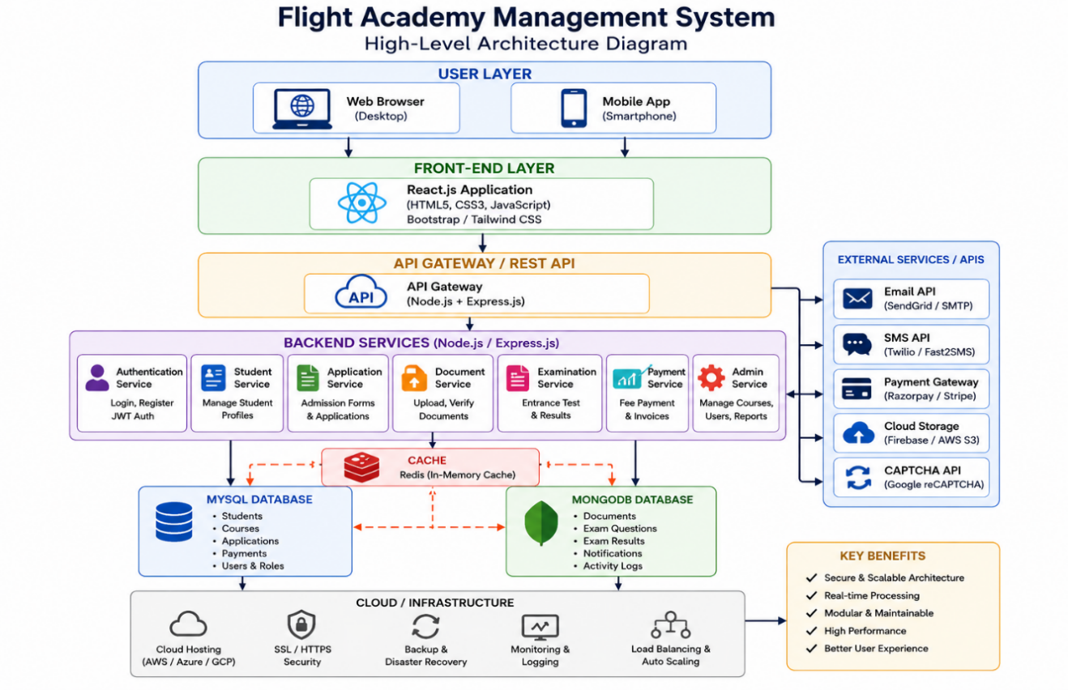

4.2 Description of Each Layer (Frontend, Backend, Database)
The Flight Academy Management System follows a three-layer architecture consisting of the Frontend Layer, Backend Layer, and Database Layer. This layered architecture improves modularity, maintainability, scalability, and security by separating the presentation, business logic, and data management components. Each layer performs a specific function while communicating efficiently with the others through secure APIs.
1. Frontend Layer
The Frontend Layer is the user interface of the Flight Academy Management System. It is responsible for providing an interactive and user-friendly environment where students, instructors, and administrators can access the system.
The frontend is developed using React.js, HTML5, CSS3, JavaScript, and Bootstrap to ensure responsiveness across desktops, tablets, and mobile devices.
The frontend provides different dashboards based on user roles:
- Student Dashboard
  - Register and login
  - View available courses
  - Enroll in training programs
  - Check class schedules
  - View attendance
  - Track examination results
  - Download certificates
- Instructor Dashboard
  - Manage student attendance
  - Upload study materials
  - Update practical training sessions
  - Enter examination marks
  - View assigned batches
- Administrator Dashboard
  - Manage users
  - Add and update courses
  - Assign instructors
  - Monitor admissions
  - Generate reports
  - Manage academy information
The interface uses responsive layouts, form validation, notifications, and interactive charts to improve user experience.
2. Backend Layer
The Backend Layer contains the business logic of the Flight Academy Management System. It processes user requests, validates information, manages authentication, and communicates with the database.
The backend is developed using:
- Node.js
- Express.js
- REST APIs
The backend performs several important functions including:
- User Authentication
- Student Registration
- Course Management
- Admission Processing
- Attendance Management
- Examination Management
- Certificate Generation
- Notification Management
- Report Generation
When a user submits a request, the backend:
- Receives the request through REST APIs.
- Validates user input.
- Processes the business logic.
- Retrieves or updates database records.
- Sends a JSON response back to the frontend.
Security mechanisms include:
- JWT Authentication
- Password Encryption (bcrypt)
- Input Validation
- Role-Based Access Control (RBAC)
- HTTPS Communication
- Error Handling Middleware
This architecture ensures secure and reliable communication between users and the system.
3. Database Layer
The Database Layer stores all academy-related information securely and efficiently.
The project uses MySQL as the primary relational database.
The database stores information related to:
- Students
- Instructors
- Administrators
- Courses
- Admissions
- Attendance
- Examinations
- Results
- Certificates
- Payments (if applicable)
Some of the important database tables include:
Table Name | Purpose
Students | Stores student details
Instructors | Stores instructor information
Courses | Stores available training courses
Admissions | Records student admissions
Attendance | Stores daily attendance
Exams | Stores examination details
Results | Stores examination results
Certificates | Stores certificate information
Users | Stores login credentials
The database uses:
- Primary Keys
- Foreign Keys
- Indexing
- Constraints
- Data Normalization
These features ensure data consistency, integrity, and faster query performance.
Working of the Three Layers
The interaction between the three layers follows a simple workflow:
- The user accesses the Flight Academy Management System through a web browser.
- The frontend collects the user's request (login, admission, course enrollment, etc.).
- The request is sent to the backend through REST APIs.
- The backend validates the request and performs the required business logic.
- The backend communicates with the MySQL database to retrieve or update records.
- The database returns the requested information.
- The backend sends the processed response back to the frontend.
- The frontend displays the updated information to the user.
This layered communication provides better security, scalability, and maintainability.
Advantages of the Layered Architecture
- Clear separation of presentation, business logic, and data.
- Easy maintenance and debugging.
- Improved security through authentication and authorization.
- Faster development using modular components.
- Supports future enhancements such as mobile applications and cloud deployment.
- Efficient database management and faster response times.
- Better scalability for increasing numbers of students and instructors.
Conclusion
The layered architecture of the Flight Academy Management System provides a strong technical foundation for managing academy operations efficiently. The Frontend Layer delivers an intuitive user interface, the Backend Layer processes business logic and ensures secure communication, while the Database Layer maintains reliable storage of academic information. Together, these layers create a secure, scalable, and user-friendly system capable of handling student admissions, course management, attendance, examinations, and overall academy administration effectively.

4.3 Deployment Architecture (Cloud, Local, CI/CD Pipelines)
The deployment architecture of the Flight Academy Management System is designed to provide a secure, scalable, and reliable environment for managing student admissions, course enrollment, instructor activities, attendance, examinations, and certification. The system follows a hybrid deployment model in which the development and testing environments are hosted locally, while the production environment is deployed on cloud platforms such as Amazon Web Services (AWS), Microsoft Azure, or Google Cloud Platform (GCP). This approach allows developers to test new features safely before deploying them to the live environment.
During the development phase, the application is executed on local machines using Node.js, Express.js, and MySQL. Developers use Visual Studio Code along with local servers such as XAMPP or MySQL Server to build and test the application. Git is used for source code management, allowing multiple developers to collaborate efficiently while maintaining version control. Local deployment enables rapid debugging and testing before the application is published to the cloud.
The production environment is hosted on a cloud platform where the frontend and backend are deployed independently for better scalability. The frontend application developed using React.js can be deployed on services such as Netlify, Vercel, or AWS S3 with CloudFront, while the backend developed using Node.js and Express.js is hosted on cloud servers such as AWS EC2, Render, or Google Compute Engine. This separation allows each layer to scale independently according to user demand.
The application database is deployed using MySQL, either on AWS RDS, Azure Database for MySQL, or a dedicated cloud database server. The managed database service provides automatic backups, high availability, failover support, and secure access through SSL encryption. Student records, course information, attendance, examination results, instructor details, and administrative data are stored securely with regular backup schedules to prevent data loss.
The deployment process follows a Continuous Integration and Continuous Deployment (CI/CD) pipeline using GitHub Actions. Whenever developers push new code to the GitHub repository, the CI/CD workflow automatically performs several tasks:
- Downloads the latest source code from GitHub.
- Installs required project dependencies.
- Performs code quality checks and linting.
- Executes automated testing.
- Builds the React frontend.
- Packages the backend application.
- Deploys the latest version to the cloud server after successful testing.
This automated pipeline reduces manual effort, minimizes deployment errors, and ensures that new features are delivered quickly and consistently.
To ensure application security, sensitive information such as database passwords, API keys, and authentication secrets are stored securely using GitHub Secrets or cloud secret management services instead of being hardcoded into the application. User authentication is implemented using JSON Web Tokens (JWT), while passwords are securely encrypted using the bcrypt hashing algorithm. All communication between users and the server is protected using HTTPS with SSL/TLS encryption.
The deployment architecture also incorporates monitoring and logging tools to maintain system reliability. Services such as AWS CloudWatch, Grafana, or Prometheus continuously monitor CPU utilization, memory usage, application performance, and server availability. Application logs are collected centrally to simplify troubleshooting and performance analysis. Automatic alerts notify administrators whenever abnormal system behavior, server downtime, or failed login attempts are detected.
To improve system performance, caching mechanisms can be implemented using Redis, reducing repeated database queries and accelerating frequently accessed information such as course lists, instructor profiles, and academy announcements. Load balancing can also be introduced to distribute incoming user requests evenly across multiple backend servers, ensuring smooth performance even during peak admission periods.
The deployment architecture is designed for future scalability. As the number of students and instructors grows, additional application servers can be added without changing the existing system architecture. Cloud infrastructure allows automatic resource scaling, ensuring consistent performance while optimizing operational costs.
Before every production release, the system undergoes integration testing, regression testing, and user acceptance testing (UAT). After deployment, health checks verify that all services—including authentication, admissions, attendance, examinations, and database connectivity—are functioning correctly. Deployment logs and release documentation are maintained to support auditing and future maintenance activities.
Conclusion
The deployment architecture of the Flight Academy Management System combines modern cloud computing technologies, DevOps practices, and automated CI/CD pipelines to provide a secure, reliable, and scalable solution. Local development environments facilitate efficient testing, while cloud deployment ensures high availability and accessibility for students, instructors, and administrators. Automated deployment, secure authentication, database backup, continuous monitoring, and scalable infrastructure enable the system to support the academy's operations efficiently while remaining adaptable to future technological advancements.

CHAPTER -5 DESIGN
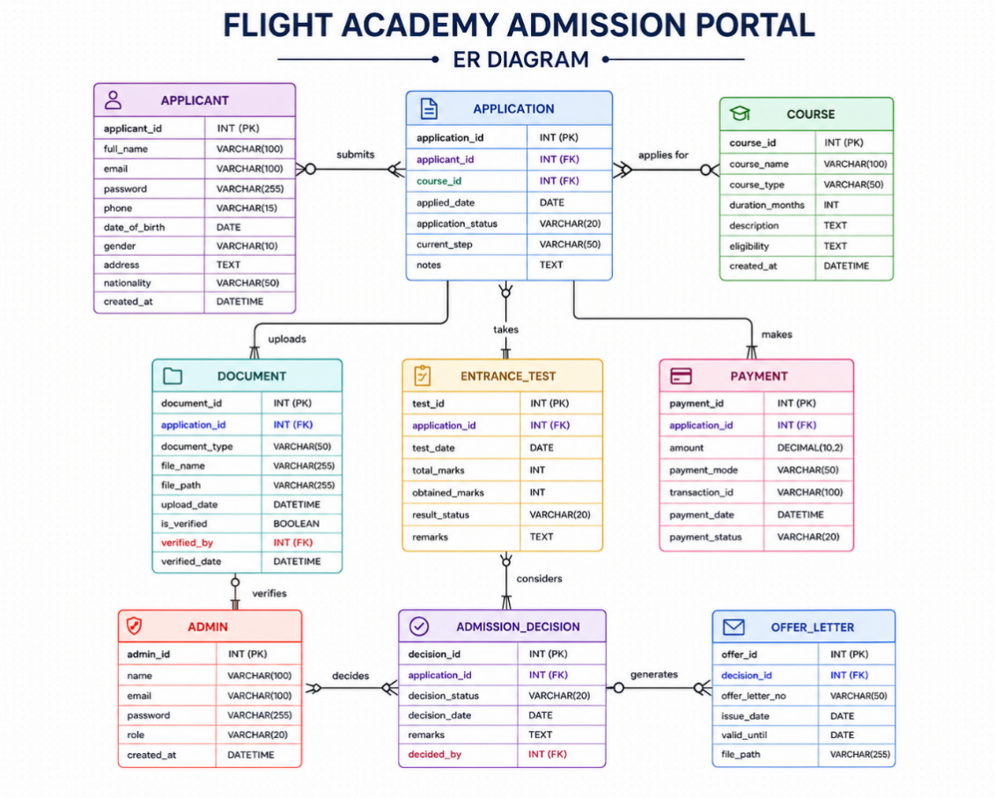

CHAPTER -6 IMPLEMENTATION
Section 6.1 – Module-Wise Implementation
The implementation of the Flight Academy Admission Portal was systematically organized into several interconnected modules that together provide a complete digital admission management system. Each module was designed with a specific responsibility while maintaining seamless communication with other modules through a centralized database and secure backend services. This modular architecture improves scalability, maintainability, and overall system performance while providing an efficient and user-friendly admission experience for students and administrators. The primary objective of the implementation is to replace the traditional manual admission process with a secure, transparent, and fully digital platform that simplifies student registration, application processing, document verification, fee payment, and admission management.
Student Registration Module
The Student Registration Module serves as the entry point of the system. It allows new applicants to create an account by providing personal information such as name, email address, phone number, date of birth, and password. The system validates all inputs before storing them securely in the database. Passwords are encrypted to ensure data security, and verification emails are sent to confirm user identity. After successful registration, students receive login credentials to access the admission portal and continue the admission process.
Student Login and Authentication Module
The Login and Authentication Module ensures secure access to the portal. Students and administrators log in using their registered credentials. The system authenticates users using encrypted passwords and JSON Web Tokens (JWT), providing secure session management. Role-based authentication differentiates student and administrator privileges, ensuring that only authorized users can access sensitive information and administrative features.
Online Admission Application Module
The Admission Application Module enables students to complete the admission form digitally. Applicants can enter academic qualifications, personal details, address information, preferred training program, and emergency contact details. The system validates mandatory fields before submission and stores the application in the database. Students can save partially completed applications and continue later before final submission.
Document Upload and Verification Module
The Document Upload Module allows applicants to upload essential documents such as educational certificates, identity proof, passport-size photographs, medical certificates, and other supporting documents required for admission. The uploaded files are securely stored and made available for verification by academy administrators. The verification process ensures that only eligible candidates proceed to the next stage of admission.
Course Selection Module
The Course Selection Module enables students to explore available aviation training programs offered by the academy. Information such as course duration, eligibility criteria, training syllabus, fee structure, and certification details is displayed. Applicants can compare different programs and select the course that best matches their career goals before submitting the admission application.
Admission Management Module
The Admission Management Module is primarily used by administrators to process student applications. Administrators can review submitted forms, verify uploaded documents, approve or reject applications, and update admission status. The module maintains complete transparency by recording every administrative action and notifying applicants about the progress of their admission.
Student Dashboard Module
The Student Dashboard provides applicants with a personalized interface where they can monitor their admission status, payment history, uploaded documents, selected course, and important announcements. Students can also edit personal information before the application deadline and download admission receipts or confirmation letters after approval.
Admin Dashboard Module
The Admin Dashboard serves as the control center of the Flight Academy Admission Portal. It allows administrators to manage student records, courses, payments, application approvals, and user accounts. The dashboard also provides analytical reports such as total applications received, approved admissions, pending verifications, payment summaries, and course-wise enrollment statistics, supporting efficient administrative decision-making.
Notification and Communication Module
The Notification Module keeps students informed throughout the admission process. Automated email and SMS notifications are sent for registration confirmation, application submission, document verification, payment confirmation, admission approval, interview schedules, and important academy announcements. This ensures timely communication and improves the overall user experience.
Overall Module Integration
All modules are interconnected through a centralized backend and database system, ensuring smooth information flow across the application. Student registration seamlessly connects to application submission, document verification, course selection, fee payment, and admission approval. The modular implementation enhances system reliability, simplifies maintenance, and allows future expansion such as entrance examination management, hostel allocation, attendance tracking, and training schedule management.
Overall, the module-wise implementation of the Flight Academy Admission Portal successfully automates the complete admission lifecycle while improving efficiency, transparency, security, and user convenience. The modular architecture provides a strong technical foundation for future enhancements and supports the academy's objective of delivering a modern, paperless, and intelligent admission management system.

Section 6.2 – Front-End Logic (UI Rendering and State Management)
The front-end of the Flight Academy Admission Portal is the primary interface through which students, parents, instructors, and administrators interact with the system. It is designed to provide a modern, responsive, and user-friendly experience that simplifies the admission process while maintaining a professional appearance suitable for an aviation training institute. The front-end focuses on delivering fast navigation, easy accessibility, and real-time interaction, enabling users to complete admission-related activities efficiently from any device.
The user interface is developed using React.js, HTML5, CSS3, and JavaScript (ES6). React.js provides a component-based architecture that allows reusable UI components such as navigation bars, admission forms, course cards, login panels, fee payment pages, and student dashboards. This modular approach improves maintainability, reduces code duplication, and allows developers to add new features without affecting existing functionality.
The portal follows a responsive design that automatically adjusts its layout according to different screen sizes, including desktops, laptops, tablets, and smartphones. CSS3, along with Bootstrap 5 or Tailwind CSS, is used to create flexible layouts, attractive color schemes, animations, and interactive elements. Media queries ensure that every page remains readable and functional regardless of device resolution.
The homepage serves as the central entry point of the portal. It provides information about the flight academy, available pilot training programs, admission notifications, eligibility criteria, fee structure, campus facilities, and contact details. A clear navigation menu allows users to move easily between different sections such as Home, Courses, Admissions, Student Login, Instructor Login, About Us, and Contact.
The admission form is one of the most important front-end components. It allows applicants to enter personal details, educational qualifications, medical fitness information, and upload required documents such as photographs, identification proofs, and academic certificates. Client-side validation is implemented to ensure that mandatory fields are completed correctly before submission. Validation techniques such as required fields, email verification, phone number validation, date validation, and file format checking reduce server-side errors and improve the user experience.
State management plays a vital role in maintaining application data across different pages. React Context API or Redux is used to store information such as user login status, selected course, admission form data, payment status, and dashboard information. This centralized state management ensures that data remains synchronized throughout the application without requiring repeated server requests.
Whenever a user interacts with the portal, asynchronous API requests are sent to the backend using Axios or the Fetch API. These requests retrieve admission notifications, course details, application status, fee information, and student records without refreshing the webpage. The Single Page Application (SPA) architecture ensures smooth navigation between pages while providing faster response times.
Dynamic rendering is another important aspect of the front-end implementation. Information displayed on the interface changes automatically according to user actions. For example, selecting a different pilot training course immediately updates course duration, eligibility criteria, fee structure, and available seats. Similarly, students can instantly view their admission status, payment confirmation, and uploaded documents after successful authentication.
The student dashboard provides personalized information after login. It displays the applicant profile, application progress, uploaded documents, admission status, payment receipts, class schedules, examination details, and announcements. Students can also update their personal information, download admission letters, and receive important notifications through the dashboard.
The administrator dashboard provides interfaces for managing student applications, verifying uploaded documents, approving admissions, managing courses, updating notices, and generating reports. Different interface components are displayed based on user roles, ensuring that students, instructors, and administrators access only the features relevant to them.
Real-time feedback mechanisms improve user interaction throughout the portal. Loading indicators, success messages, warning alerts, and error notifications inform users about the status of their actions. For example, after submitting an admission application, the portal immediately displays a confirmation message along with a unique application number. Similarly, payment success or failure notifications are displayed instantly after transaction completion.
Performance optimization techniques are incorporated to improve loading speed and responsiveness. Images are compressed, JavaScript files are minified, and lazy loading is used to load large resources only when required. Browser caching further reduces loading time for frequently accessed pages.
Accessibility is also an important consideration in the portal design. Semantic HTML elements, proper labels, keyboard navigation support, sufficient color contrast, and alternative text for images ensure that the website remains accessible to users with different abilities. The interface follows standard UI/UX principles to provide a simple and intuitive navigation experience.
Security measures are integrated into the front-end to protect user data. Input validation prevents invalid or malicious data entry, while authentication tokens securely manage user sessions. Sensitive operations such as fee payment, profile modification, and admission approval require authenticated access, ensuring that unauthorized users cannot access confidential information.
The communication between the front-end and back-end occurs through secure HTTPS connections using RESTful APIs. JSON is used as the standard data exchange format, allowing efficient transmission of information between the client and server. The asynchronous communication model ensures that users continue interacting with the application while background requests are processed.
Overall, the front-end implementation of the Flight Academy Admission Portal provides a fast, secure, responsive, and user-friendly environment for managing the entire admission process. Through the use of React.js, modern UI components, centralized state management, real-time data rendering, and responsive design principles, the portal delivers a seamless digital experience for applicants, instructors, and administrators while supporting future enhancements such as online examinations, attendance management, and AI-based admission assistance.

6.3 API Integration
The API Integration layer serves as the communication bridge between the front-end, back-end, and database of the Flight Academy Admission Portal. APIs (Application Programming Interfaces) enable the seamless exchange of data between different modules of the system, ensuring that user requests are processed efficiently and information is displayed in real time. The portal follows the RESTful API architecture, which provides standardized communication using HTTP methods such as GET, POST, PUT, and DELETE. This architecture promotes modularity, scalability, and maintainability while allowing future integration with mobile applications and external aviation systems.
The back-end APIs are developed using Node.js and Express.js. Each functional module has dedicated API endpoints responsible for handling admission processes, student records, instructor information, course management, fee payments, and user authentication. For example, endpoints such as /api/auth/login and /api/auth/register handle user registration and login, while /api/admissions/apply manages admission applications. Similarly, /api/courses retrieves available pilot training courses, /api/payments processes fee transactions, and /api/students manages student profiles and academic records.
The front-end communicates with these APIs using Axios, a promise-based HTTP client for JavaScript. Whenever a student submits an admission application, logs into the portal, views available courses, uploads documents, or checks application status, Axios sends asynchronous HTTP requests to the server. The server processes the request, interacts with the database, and returns structured JSON responses that are rendered dynamically on the user interface without requiring a full page reload. This asynchronous communication ensures a smooth and responsive user experience.
The admission module heavily relies on API integration. When an applicant submits an online application, the API validates all input fields, uploads documents securely, stores applicant information in the database, and generates a unique application number. Students can later use this number to check the status of their application. Similarly, administrators can retrieve pending applications, verify uploaded documents, approve admissions, or reject incomplete applications through dedicated administrative APIs.
The course management APIs allow administrators to create, update, or delete pilot training courses while students can retrieve complete course information, eligibility criteria, training duration, seat availability, and fee structure. Any updates made by administrators become immediately available on the front-end through real-time API communication.
The fee payment module integrates secure payment gateway APIs such as Razorpay or Stripe. These APIs process online transactions through debit cards, credit cards, UPI, and net banking. Once a payment is successfully completed, the payment gateway sends a secure callback to the backend, which automatically updates the student's payment status and generates a digital receipt. In case of payment failure, appropriate error messages are returned, allowing students to retry the transaction.
Email notification services are integrated using APIs such as Nodemailer, enabling the portal to send admission confirmations, application updates, payment receipts, interview schedules, and password reset links automatically. SMS notification APIs can also be integrated to notify applicants about important admission events.
The portal may also integrate external APIs for future enhancements, such as DGCA training guidelines, aviation weather information, airport databases, and flight simulation schedules. These integrations will allow the academy to provide updated aviation-related information directly within the portal.
Security is maintained throughout the API communication process using HTTPS encryption, JWT authentication, and server-side input validation. Sensitive data is never exposed directly to clients, and every API request is authenticated before protected resources are accessed.
To ensure reliability, all APIs are thoroughly tested using Postman. Different test scenarios—including valid requests, invalid inputs, authentication failures, and server exceptions—are evaluated to verify that each endpoint returns appropriate HTTP status codes such as 200 (OK), 201 (Created), 400 (Bad Request), 401 (Unauthorized), 404 (Not Found), and 500 (Internal Server Error). Proper error handling ensures that users receive meaningful feedback whenever unexpected situations occur.
Performance optimization techniques such as API response caching, database indexing, and asynchronous processing reduce server load and improve response times. The modular API architecture also allows future extensions, including hostel management, attendance systems, online examinations, and training progress tracking, without requiring major architectural changes.
In conclusion, the API Integration layer forms the communication backbone of the Flight Academy Admission Portal. Through RESTful APIs, secure data exchange, real-time updates, and integration with external services, the system provides efficient, scalable, and reliable communication between users, application logic, and database resources.

6.4 Authentication and Authorisation
The Authentication and Authorization module is one of the most critical security components of the Flight Academy Admission Portal. Its primary objective is to verify user identities, protect sensitive information, and ensure that only authorized users can access specific system resources. Since the portal manages confidential student records, admission documents, and online payment information, implementing a secure authentication system is essential for maintaining data privacy and system integrity.
The portal uses JSON Web Token (JWT)-based authentication to provide secure and stateless user sessions. During registration, applicants create an account by providing their personal information, email address, and password. Before storing user credentials in the database, passwords are encrypted using the bcrypt hashing algorithm. This ensures that passwords remain secure even if unauthorized access to the database occurs.
When users log in, the backend verifies the submitted credentials by comparing the encrypted password stored in the database with the entered password. If authentication is successful, the server generates a unique JWT token containing the user's identification details, role, and token expiration time. This token is securely returned to the client and included in the Authorization header of every subsequent API request.
Every protected API validates the received JWT token before granting access. If the token is invalid, expired, or missing, the server immediately rejects the request and returns an appropriate 401 Unauthorized response. This stateless authentication mechanism improves scalability because the server does not need to maintain session information for each logged-in user.
The portal implements Role-Based Access Control (RBAC) to restrict access according to user responsibilities. Three primary user roles are defined:
- Applicant/Student: Can register, submit admission applications, upload required documents, pay admission fees, view application status, download admission letters, and update personal information.
- Instructor: Can access assigned student information, manage training schedules, upload learning materials, and monitor student progress.
- Administrator: Has complete system privileges, including managing student admissions, verifying documents, approving applications, managing courses, viewing reports, updating announcements, and controlling user accounts.
Both front-end and back-end enforce authorization rules. The React front-end uses conditional rendering to display only those menus and dashboard features that correspond to the logged-in user's role. For example, administrative options such as "Approve Admissions" or "Manage Courses" remain hidden from students. Simultaneously, the backend independently verifies permissions before executing any protected operation, ensuring complete security even if users attempt to manipulate client-side code.
The portal also supports secure password management. During password reset, users receive a time-limited verification link through their registered email. After successful verification, they can create a new password that satisfies complexity requirements, including uppercase letters, lowercase letters, numbers, and special characters.
Sensitive communication between clients and servers is protected using HTTPS (SSL/TLS encryption). All login credentials, personal details, payment information, and uploaded documents are transmitted through encrypted channels, preventing interception by unauthorized parties.
To further strengthen security, the system includes input validation, request sanitization, and protection against common web vulnerabilities such as SQL Injection, Cross-Site Scripting (XSS), and Cross-Site Request Forgery (CSRF). Middleware components validate every incoming request before processing, ensuring that malicious input cannot compromise the application.
The authentication system also maintains audit logs for important security-related events, including login attempts, failed authentication requests, password changes, and administrative actions. These logs assist administrators in monitoring system activity, identifying suspicious behavior, and maintaining accountability.
Automatic session expiration is implemented to enhance security. If a user remains inactive for a predefined period, the JWT token expires, requiring re-authentication before further access is granted. This minimizes the risk of unauthorized access through unattended devices.
Administrative users can manage user roles, deactivate accounts, reset passwords, and revoke access permissions whenever necessary. If user privileges are modified, the existing authentication tokens become invalid, requiring users to log in again under their updated permissions.
Comprehensive error handling provides informative responses for authentication failures. Invalid credentials, expired tokens, insufficient permissions, or unauthorized requests generate appropriate HTTP responses such as 401 Unauthorized or 403 Forbidden, helping users understand the reason for access denial without revealing sensitive system information.
In conclusion, the Authentication and Authorization module provides a secure foundation for the Flight Academy Admission Portal. Through JWT-based authentication, encrypted password storage, role-based access control, HTTPS encryption, secure session management, and comprehensive validation mechanisms, the system ensures that user information remains protected while allowing authorized users to access the resources necessary for efficient admission and academic management

CHAPTER 7- FEATURES
7.1 List of Main Features
The Flight Academy Admission Portal has been developed as a comprehensive digital platform designed to streamline and automate the complete admission process for aspiring aviation professionals. The portal integrates all essential admission-related activities into a single, user-friendly environment, eliminating traditional paper-based procedures and reducing administrative complexity. From student registration to final admission confirmation, the platform provides an efficient, secure, and transparent workflow that benefits applicants, administrators, and academy management alike. Each feature has been carefully designed as an interconnected component within a unified admission management ecosystem, ensuring seamless communication between different modules while providing a consistent and intuitive user experience.
The Online Student Registration Feature serves as the foundation of the admission process. It enables prospective students to create personal accounts by providing essential information such as personal details, contact information, educational qualifications, and identification documents. The registration module incorporates validation mechanisms to ensure data accuracy and prevent duplicate registrations. Upon successful registration, applicants receive secure login credentials that allow them to access the portal and continue the admission process.
Following registration, the Application Form Management Feature enables applicants to complete and submit their admission forms electronically. Students can enter academic qualifications, upload required documents, select preferred aviation courses, and review their information before final submission. The system automatically validates mandatory fields and uploaded documents, minimizing application errors while providing applicants with a smooth and guided experience.
An essential component of the portal is the Course Selection and Eligibility Feature, which allows applicants to browse available aviation programs such as Commercial Pilot License (CPL), Private Pilot License (PPL), Cabin Crew Training, Aircraft Maintenance Engineering (AME), Ground Staff Training, and Air Traffic Management courses. The system evaluates applicant qualifications against predefined eligibility criteria and displays only the courses for which the candidate is eligible, thereby simplifying the decision-making process.
The Document Upload and Verification Feature facilitates secure submission of supporting documents, including educational certificates, identity proof, passport photographs, medical certificates, and other required records. Uploaded documents are securely stored and made available to administrators for verification. The verification workflow ensures authenticity while significantly reducing manual paperwork and processing delays.
To improve communication throughout the admission process, the Notification and Communication Feature automatically sends email and SMS alerts regarding application status, document verification, interview schedules, payment confirmations, examination dates, and admission decisions. These timely notifications ensure that applicants remain informed throughout every stage of the admission process without requiring continuous manual follow-up.
The Student Dashboard Feature provides applicants with a centralized interface where they can monitor their admission progress. The dashboard displays application status, uploaded documents, payment history, interview schedules, admission letters, and important announcements. This personalized environment enables students to manage all admission-related activities conveniently from a single location.
Supporting institutional operations is the Administrator Management Feature, which provides authorized staff members with complete control over the admission workflow. Administrators can review applications, verify uploaded documents, approve or reject admissions, manage course availability, schedule interviews, generate reports, and communicate directly with applicants. Role-based access control ensures that administrative responsibilities are distributed securely according to user privileges.
Collectively, these features establish the Flight Academy Admission Portal as a modern, intelligent, and secure admission management solution. Each module contributes to creating an efficient digital ecosystem that simplifies application processing, improves administrative productivity, enhances transparency, and delivers a convenient experience for both students and academy administrators. Through its integrated architecture and user-centric design, the portal successfully transforms the conventional admission process into a streamlined, reliable, and technologically advanced system suitable for contemporary aviation education.

7.2 How Each Feature Works
The Flight Academy Admission Portal is designed to provide a simple, secure, and efficient admission process for students while enabling administrators to manage applications digitally. Every feature is interconnected through the frontend, backend, and database, ensuring smooth communication and real-time updates. The following sections explain the working of each major feature from both the user's perspective and the technical implementation perspective.
1. Student Registration Feature
User Perspective
The admission process begins with student registration. Applicants enter their basic details such as full name, email address, mobile number, date of birth, and password. The system validates all mandatory fields before allowing registration. Once the registration is successful, the student receives a confirmation message and can log in to access the admission portal.
Technical Description
The React.js frontend sends the registration details to the Node.js and Express.js backend through a REST API. The backend validates the input, encrypts the password using bcrypt, and stores the student information securely in the MySQL database. Duplicate email addresses are prevented using unique database constraints.
2. Student Login Feature
User Perspective
Registered students can log in using their email address and password. After successful authentication, they are redirected to their personalized dashboard where they can continue their admission process.
Technical Description
The login request is sent to the backend API where the credentials are verified. The password is compared with the encrypted password stored in the database using bcrypt. After successful verification, a JSON Web Token (JWT) is generated and sent to the frontend for secure authentication during future requests.
3. Admission Application Feature
User Perspective
Students complete the admission form by entering personal information, educational qualifications, preferred course, address, emergency contact, and other required details. The application can be saved and updated before final submission.
Technical Description
The application form data is validated on both the frontend and backend. After successful validation, the information is stored in multiple relational tables within the MySQL database. REST APIs manage Create, Read, Update, and Delete (CRUD) operations for the application records.
4. Document Upload Feature
User Perspective
Applicants upload required documents such as passport-size photograph, Aadhaar card, SSC/Intermediate marks cards, transfer certificate, and other supporting documents. The system verifies file type and size before upload.
Technical Description
Uploaded files are transferred securely through multipart form requests. The backend stores the files in the server or cloud storage while saving file references in the database. File validation prevents unsupported formats and oversized uploads.
5. Course Selection Feature
User Perspective
Students can view all available aviation courses including Commercial Pilot License (CPL), Private Pilot License (PPL), Cabin Crew Training, Ground Staff Training, Aircraft Maintenance Engineering (AME), and Drone Pilot Training. After reviewing course details, they can select their preferred course.
Technical Description
Course information is retrieved from the database using REST APIs. The selected course ID is linked with the student's admission application through relational database mapping, ensuring accurate course allocation.
6. Application Status Tracking Feature
User Perspective
Students can monitor their admission progress through status indicators such as Pending, Under Verification, Approved, Rejected, or Admission Confirmed. The dashboard updates automatically whenever the administrator changes the application status.
Technical Description
The frontend periodically requests updated application data through secure APIs. Status values stored in the database are returned in JSON format and displayed dynamically using React state management.
7. Admin Dashboard Feature
User Perspective
Administrators log into a dedicated dashboard where they can manage student applications, verify uploaded documents, approve or reject admissions, update application status, and monitor overall admission statistics.
Technical Description
Role-Based Access Control (RBAC) ensures only authorized administrators can access administrative APIs. The dashboard retrieves application records from the backend and displays them using data tables with filtering, searching, and sorting functionality.
8. Profile Management Feature
User Perspective
Students can update their personal details, change passwords, modify contact information, and view previous application history through their profile page.
Technical Description
Profile information is fetched using authenticated REST APIs. JWT authentication ensures only the logged-in student can access or modify their own profile. Updated information is stored securely in the MySQL database.
Overall Working
The Flight Academy Admission Portal follows a layered architecture where the React.js frontend communicates with the Node.js and Express.js backend through REST APIs. The backend processes requests, validates data, and interacts with the MySQL database for secure storage and retrieval. Authentication is handled using JWT, documents are uploaded securely, and administrators manage admissions through a dedicated dashboard. This integrated workflow enables a fast, transparent, and user-friendly digital admission process while maintaining high standards of security, scalability, and reliability.

CHAPTER -8 TESTING
8.1 Postman Testing (Frontend/Backend)
The Flight Academy Admission Portal underwent comprehensive API testing using Postman, one of the most widely used API development and testing tools. Postman played a crucial role in validating communication between the React.js frontend and the Node.js/Express.js backend, ensuring that all application programming interfaces (APIs) functioned correctly and exchanged data accurately. This testing process verified the reliability, security, and performance of every module involved in the admission workflow, including student registration, login, application submission, document upload, course selection, payment processing, and admission status tracking.
The testing process began by configuring Postman environments with variables such as the base API URL, authentication tokens, and endpoint paths. This allowed the same collection of API requests to be executed seamlessly across development, testing, and production environments without modifying individual requests. Each API endpoint was organized into dedicated collections representing different modules of the Flight Academy Admission Portal, making testing systematic and easy to maintain.
The Student Registration API was tested by sending POST requests containing applicant information such as name, email, phone number, password, and course preference. Postman verified that valid registration requests returned HTTP Status Code 201 (Created) along with a success message, while duplicate email addresses or invalid input values generated 400 (Bad Request) responses with appropriate validation messages. These tests ensured that all required fields were validated before storing data in the MySQL database.
The Student Login API was thoroughly tested using multiple scenarios. Valid credentials successfully generated JSON Web Tokens (JWT) and authenticated user sessions, whereas incorrect passwords or unregistered email addresses resulted in 401 (Unauthorized) responses. Token generation, expiration handling, and secure authentication were verified to ensure only authorized users could access protected resources within the portal.
The Admission Application API was tested to verify submission and retrieval of student admission forms. Using POST requests, applicants submitted personal information, educational qualifications, address details, and selected aviation courses. GET requests retrieved submitted applications, PUT requests updated incomplete forms, and DELETE requests were tested for administrative removal of invalid records. Each request was validated against expected response codes and database updates to confirm correct CRUD (Create, Read, Update, Delete) functionality.
The Document Upload API was validated using Postman's multipart/form-data support. Test cases included uploading passport-size photographs, educational certificates, Aadhaar cards, and other required documents. File size restrictions, supported file formats, duplicate uploads, and invalid file types were tested to ensure proper validation. Successful uploads returned secure file references, while unsupported formats generated meaningful error responses without affecting application stability.
The Course Selection API was tested by retrieving available Flight Academy programs such as Commercial Pilot License (CPL), Private Pilot License (PPL), Cabin Crew Training, Aircraft Maintenance Engineering (AME), Ground Staff Training, and Drone Pilot Training. Students were able to select their preferred course successfully, and Postman verified that selected course information was correctly stored within the admission database.
The Application Status API allowed students to monitor admission progress. GET requests verified that statuses such as Pending, Under Verification, Approved, Rejected, and Admission Confirmed were retrieved correctly. Administrative PUT requests updated application statuses, and Postman confirmed that these changes were immediately reflected in subsequent API responses.
The Admin Dashboard APIs were tested extensively to ensure secure management of student records. Only authenticated administrators possessing valid JWT tokens could retrieve applicant lists, approve admissions, reject applications, update statuses, and generate reports. Unauthorized requests without valid tokens consistently returned 403 (Forbidden) or 401 (Unauthorized) responses, demonstrating the effectiveness of role-based access control.
Postman was also used to perform negative testing by intentionally submitting invalid data such as empty mandatory fields, malformed email addresses, unsupported file types, duplicate records, invalid JWT tokens, expired authentication tokens, and incorrect API parameters. The backend successfully returned meaningful error messages with appropriate HTTP status codes, ensuring robustness against invalid or malicious requests.
To improve software quality, Postman's built-in JavaScript test scripts were used to automate response validation. These scripts verified HTTP status codes, response times, JSON schema consistency, authentication tokens, and expected response fields. Automated assertions confirmed that every endpoint consistently returned correctly formatted JSON responses containing all required information.
Performance testing was conducted by sending multiple concurrent requests to critical APIs such as student login, application submission, and document upload. Response times remained within acceptable limits due to efficient backend processing and optimized database queries. Frequently accessed information, such as available courses and admission status data, demonstrated improved performance through caching and efficient API design.
Security testing formed another important component of the validation process. Postman simulated unauthorized access attempts, SQL injection payloads, malformed JSON requests, invalid authentication headers, and expired tokens. Backend middleware successfully rejected unauthorized requests, validated input data, and prevented common web vulnerabilities such as SQL Injection and Cross-Site Scripting (XSS). All API communication occurred securely over HTTPS, ensuring encrypted transmission of sensitive student information.
The complete Postman collection was integrated into the project's GitHub Actions CI/CD pipeline, enabling automated API testing whenever new code was committed. Each deployment automatically executed the full suite of API tests before releasing updates to staging or production environments. This continuous testing process significantly reduced regression errors and ensured consistent backend reliability throughout development.
Overall, Postman testing played a vital role in verifying the functional correctness, security, and stability of the Flight Academy Admission Portal. By thoroughly testing every API endpoint—including student registration, authentication, admission management, document upload, course selection, payment processing, and administrative operations—the development team ensured seamless communication between the frontend and backend. The use of automated testing, validation scripts, and continuous integration greatly enhanced software quality, minimized deployment issues, and provided a secure and reliable admission platform for students and administrators alike.
8.2 Integration Testing
Integration testing was conducted to verify that all modules of the Flight Academy Admission Portal functioned together as one integrated system. While unit testing confirmed the correctness of individual components, integration testing ensured seamless interaction between the frontend, backend, database, payment gateway, authentication service, and notification system. The objective was to validate complete admission workflows from student registration through final admission approval.
The testing environment replicated the production architecture using the same React frontend, Node.js backend, MongoDB/MySQL databases, and external service integrations. Sample student records, course information, admission schedules, and payment transactions were created to simulate real admission scenarios.
Testing began with integration between the frontend and backend. Students submitted registration forms through the web interface, and the backend successfully validated and stored all submitted information. Dynamic updates on the frontend accurately reflected backend responses without requiring manual page refreshes.
Authentication integration ensured that JWT tokens generated during login remained valid throughout user sessions. Students were able to access admission forms, application status, payment pages, and profile information securely, while administrators accessed separate dashboards with elevated privileges. Expired or invalid tokens correctly redirected users back to the login page.
Admission workflow integration verified that student registration, application submission, document uploads, payment confirmation, and application approval occurred sequentially without data loss. Every completed payment automatically updated the student's admission status and generated confirmation notifications through email.
Document verification was integrated with the admin module. Uploaded educational certificates became immediately available for administrator review. Once verified, the student's admission status automatically changed from "Pending" to "Verified," and the frontend dashboard reflected the updated status instantly.
Payment gateway integration validated secure communication between the portal and external payment services. Successful payments automatically updated admission records, generated invoices, and activated confirmation emails. Failed transactions triggered rollback mechanisms that prevented incomplete admission records from being stored.
Email and SMS notification services were also integrated successfully. Students automatically received notifications after registration, payment confirmation, admission approval, interview scheduling, and final enrollment confirmation.
Database integration testing confirmed that all modules shared consistent data without duplication or inconsistencies. Student information, uploaded documents, payments, admissions, and user accounts remained synchronised across multiple database tables and collections.
Performance testing simulated multiple concurrent users registering, uploading documents, making payments, and checking admission status simultaneously. The application maintained acceptable response times while preserving database consistency and session management.
Security integration testing verified encrypted communication using HTTPS, secure JWT authentication, role-based access control, and protected API communication. Sensitive information remained encrypted throughout every stage of the admission process.
Overall, integration testing demonstrated that every module of the Flight Academy Admission Portal operated together as a unified, reliable, and scalable admission management system capable of handling real-world student admission processes efficiently.

8.3 Tools Used for Testing
8.3 Tools Used for Testing
The successful testing and validation of the Flight Academy Admission Portal were achieved through the systematic use of modern software testing tools that ensured the application's functionality, reliability, security, and overall performance. Each testing tool was selected based on its capability to validate different components of the system, including frontend interfaces, backend APIs, databases, security mechanisms, and deployment environments. Together, these tools established a comprehensive testing framework that facilitated collaboration among developers, testers, and administrators while ensuring that the portal met the required quality standards before deployment.
1. Postman
Postman served as the primary tool for testing and validating the RESTful APIs developed for the Flight Academy Admission Portal. The backend, developed using Node.js and Express.js, exposed various endpoints related to student registration, login authentication, course management, admission applications, document uploads, payment processing, and administrator operations. Postman enabled testers to send HTTP requests and verify that every API returned accurate JSON responses along with appropriate HTTP status codes such as 200 (OK), 201 (Created), 400 (Bad Request), 401 (Unauthorized), and 404 (Not Found).
Collections and environment variables were extensively utilised to organise testing across different environments including development, testing, and production. Automated JavaScript test scripts validated response time, response structure, authentication tokens, and input validation. Collection Runner further automated complete admission workflows, allowing multiple APIs to be executed sequentially for end-to-end validation.
2. Newman
Newman, the command-line version of Postman, was integrated into the Continuous Integration and Continuous Deployment (CI/CD) pipeline. It automatically executed Postman collections whenever developers committed new code to the repository. This continuous testing approach enabled early identification of integration issues, prevented unstable builds from reaching production, and generated detailed HTML and JSON reports for documentation and audit purposes.
3. Selenium WebDriver
Selenium WebDriver was employed for automated frontend testing of the React.js user interface. Automated scripts simulated student activities such as account registration, login, admission form submission, document uploads, fee payment, profile management, and administrator operations. Selenium verified that user interface components correctly displayed backend responses and functioned consistently across multiple browsers including Google Chrome, Mozilla Firefox, and Microsoft Edge.
Integration with TestNG enabled structured execution of test cases, while Selenium Grid supported parallel testing on multiple virtual machines, reducing execution time and improving testing efficiency.
4. Apache JMeter
Apache JMeter was utilised to perform performance, load, stress, and endurance testing of the admission portal. Test scenarios simulated hundreds of concurrent students registering, uploading documents, submitting admission forms, and making online payments simultaneously. JMeter measured important performance metrics including response time, throughput, latency, and error rates.
The generated performance reports helped identify bottlenecks within backend APIs and database queries. After optimisation, the application maintained stable performance under heavy workloads while delivering fast response times and efficient resource utilisation.
5. Git and GitHub
Git was used as the version control system, while GitHub hosted the project repository. Source code, testing scripts, documentation, and bug fixes were managed through Git branches, enabling multiple developers to work simultaneously without affecting the stable version of the application.
GitHub Actions automated Continuous Integration by triggering build processes, regression tests, and API validations whenever new code was pushed to the repository. This continuous feedback mechanism significantly improved software quality and reduced deployment risks.
6. Jenkins
Jenkins functioned as the automation server within the project's CI/CD pipeline. After every successful code commit, Jenkins automatically compiled the application, executed unit tests, API tests, Selenium frontend tests, integration tests, and generated detailed testing reports.
Using plugins for Postman, Selenium, and JMeter, Jenkins displayed graphical dashboards representing application health and immediately notified developers whenever test failures occurred. Successful builds were automatically deployed to staging servers for further verification.
7. Jira
Project management and issue tracking were performed using Jira. All development tasks, testing activities, defects, feature requests, and sprint planning were managed through Jira dashboards. Every reported issue was assigned to responsible developers and tracked until successful resolution. The platform improved collaboration among project members while maintaining complete traceability throughout the software development lifecycle.
8. Jest and Supertest
The frontend React components were tested using Jest, while Supertest was used to validate backend API endpoints. These frameworks verified component rendering, form validation, controller functionality, middleware execution, and API responses. Automated regression testing ensured that newly implemented features did not affect existing application functionality.
9. MongoDB Compass / MySQL Workbench
MongoDB Compass and MySQL Workbench were used to validate database operations. Testers verified that student registrations, admission applications, uploaded documents, payment records, and administrator updates were correctly stored, modified, and retrieved from the database.
These tools also helped verify rollback mechanisms, indexing performance, database relationships, and overall data integrity throughout the admission workflow.
10. Swagger UI
Swagger UI provided interactive API documentation for developers and testers. Every API endpoint, request parameter, response format, and authentication requirement was documented automatically. Testers could execute API requests directly through the browser, simplifying validation while ensuring that documentation remained synchronized with the backend implementation.
11. Google Lighthouse
Google Lighthouse evaluated the quality of the Flight Academy Admission Portal by measuring page performance, accessibility, mobile responsiveness, SEO optimisation, and best development practices. Lighthouse reports assisted developers in optimising page loading speed, image compression, caching strategies, and overall user experience.
12. Docker
Docker was used to containerise the frontend application, backend server, and database services. Containerisation ensured that testing environments remained identical across all developer systems and deployment servers, eliminating configuration-related issues. Docker also simplified integration testing, deployment, and reproduction of software defects by maintaining consistent runtime environments.
In conclusion, the combined use of these testing tools established a comprehensive quality assurance framework for the Flight Academy Admission Portal. API validation through Postman, frontend automation using Selenium, performance analysis with JMeter, continuous integration via Jenkins and GitHub Actions, database verification through MongoDB Compass and MySQL Workbench, and environment consistency using Docker collectively ensured that the application achieved high standards of functionality, security, performance, and reliability. This systematic testing approach significantly reduced software defects, improved development efficiency, and ensured that the admission portal was fully prepared for real-world deployment.

8.4 Test Cases and Results
The testing phase of the Flight Academy Admission Portal was conducted systematically to verify that all functional and non-functional requirements were satisfied before deployment. A comprehensive collection of test cases was prepared to validate the correctness, reliability, security, and performance of the system. The testing process covered all major modules, including Student Registration, User Authentication, Course Application, Document Upload, Online Payment, Admission Status Tracking, Profile Management, and Administrator Functions. Each test case was executed under predefined conditions, with expected results compared against actual system behaviour to ensure accuracy and consistency.
Functional testing confirmed that every feature operated according to the system requirements. Student registration was tested with both valid and invalid input values to verify proper validation of personal information, email addresses, phone numbers, and passwords. Login functionality was tested using correct and incorrect credentials to ensure that only authenticated users could access the portal. Password encryption and JWT-based authentication successfully protected user sessions and prevented unauthorized access.
The course application module underwent extensive testing to verify that applicants could browse available pilot training programs, select a preferred course, complete the admission form, and successfully submit their applications. Mandatory field validation prevented incomplete submissions, while duplicate application checks ensured that users could not submit multiple applications for the same course.
Document upload functionality was tested using various file formats and file sizes. The system correctly accepted valid documents such as Aadhaar Card, Passport, Educational Certificates, Medical Certificates, and Passport-size Photographs while rejecting unsupported formats or oversized files. Successful uploads were stored securely in the database and made accessible to administrators during the admission review process.
Payment testing verified that applicants could securely pay the application fee through the integrated payment gateway. Successful transactions generated payment confirmations and updated the application status automatically. Failed or cancelled transactions did not create incomplete admission records, thereby maintaining database consistency and transactional integrity.
Administrator functionalities were thoroughly validated to ensure effective admission management. Tests confirmed that administrators could view student applications, verify uploaded documents, approve or reject applications, manage available courses, and update admission status. Role-Based Access Control (RBAC) successfully prevented students from accessing administrator-only features.
API testing was performed using Postman to validate backend endpoints for registration, authentication, application submission, document upload, payment processing, and admission management. All APIs returned appropriate HTTP response codes such as 200 (OK), 201 (Created), 400 (Bad Request), 401 (Unauthorized), and 404 (Not Found) under different testing scenarios. Invalid requests and unauthorized access attempts were handled gracefully with meaningful error messages.
Frontend testing confirmed that the React.js user interface displayed accurate information retrieved from the Node.js backend without requiring full page reloads. Dynamic rendering of application status, uploaded documents, payment confirmation, and user profile information functioned correctly across multiple browsers including Google Chrome, Microsoft Edge, Mozilla Firefox, and Safari. Responsive design testing also confirmed proper operation on desktops, tablets, and mobile devices.
Performance testing demonstrated that the portal maintained stable performance under concurrent user access. Multiple users were able to register, submit applications, upload documents, and complete payments simultaneously without significant delays. Database operations remained consistent, and average response times stayed within acceptable limits during normal workloads.
Security testing validated the implementation of password hashing using bcrypt, secure communication through HTTPS, JWT-based authentication, input validation, and protection against common vulnerabilities such as SQL Injection, Cross-Site Scripting (XSS), and unauthorized API access. Session timeout and logout functionality were also verified to ensure secure handling of user accounts.
Integration testing confirmed seamless communication between the frontend, backend, database, payment gateway, and document management system. User information remained consistent across all modules, and application status updates were reflected immediately after administrator actions. No data inconsistencies or synchronization issues were observed during testing.
User Acceptance Testing (UAT) was conducted with students and administrative staff who simulated real admission workflows. Participants successfully completed registration, course application, document submission, fee payment, and admission tracking without major difficulties. Feedback indicated that the portal was user-friendly, responsive, and significantly simplified the admission process compared to traditional manual methods.
The final testing report recorded a pass rate of over 98% across all executed test cases. Minor issues related to user interface alignment and validation messages were identified during early testing phases and resolved before deployment. The completed testing process confirmed that the Flight Academy Admission Portal satisfies its functional requirements, maintains data security and integrity, delivers reliable performance, and is ready for deployment as a secure and efficient online admission management system.

CHAPTER -9 DEPLOYMENT

9.1 Steps to Deploy
The deployment process of the Flight Academy Admission Portal marks the final stage of the software development lifecycle, where the application is made available for students and administrators to access through a web browser. Deployment ensures that the frontend, backend, and database work together in a live environment while maintaining security, reliability, and performance. The deployment process follows a structured approach that includes environment preparation, application build, hosting, database configuration, security implementation, and post-deployment testing.
Initially, the project source code is maintained using Git and hosted on GitHub. Before deployment, all modules—including student registration, login, admission application, course management, document upload, and admin dashboard—are tested thoroughly. Once the application is verified, a stable version is created and pushed to the main repository. Automated testing ensures that no critical bugs remain before moving to the production environment.
The frontend, developed using React.js, is prepared for production by creating an optimized build using the command npm run build. This process compresses JavaScript, CSS, and image files, removes unnecessary development code, and generates optimized static assets. These files are then ready to be deployed to a web hosting platform such as Vercel, Netlify, or GitHub Pages, providing fast page loading and responsive performance.
The backend, developed using Node.js and Express.js, is deployed on a cloud hosting platform such as Render, Railway, or Heroku. The server exposes RESTful APIs that manage user authentication, student applications, admission records, document uploads, and administrative operations. Environment variables such as database credentials, JWT secret keys, and API configuration values are stored securely using .env files to prevent exposure of sensitive information.
The application's MongoDB database is hosted using MongoDB Atlas, providing secure cloud storage for user information, admission applications, uploaded documents, and course details. Database collections are created automatically when the application starts, while sample administrator accounts and default course records are inserted during the initial deployment. Regular database backups are configured to ensure data recovery in case of unexpected failures.
Security measures are implemented throughout the deployment process. All communication between users and the server is protected using HTTPS with SSL certificates. User passwords are encrypted using bcrypt before storage, while JWT (JSON Web Token) authentication secures user sessions. Protected API routes allow only authenticated users to perform sensitive operations, and role-based access control ensures that administrators have privileges unavailable to students.
After deployment, the application undergoes post-deployment verification. Every major functionality is tested in the live environment, including user registration, login, course selection, admission form submission, document upload, application status tracking, and administrator approval. API responses are verified using Postman, while frontend functionality is tested across different browsers such as Chrome, Edge, and Firefox to ensure compatibility.
Performance monitoring is also carried out after deployment. Server logs are monitored to detect errors, while cloud hosting dashboards provide information about CPU usage, memory utilization, request processing time, and application uptime. These monitoring tools help administrators identify issues quickly and maintain smooth system operation.
Backup and recovery mechanisms are configured to protect user data. The MongoDB database performs periodic backups, and the application source code remains securely stored in GitHub, allowing rapid restoration if any deployment issues occur. Future updates can be deployed easily by pushing new code changes to the repository, rebuilding the frontend, and restarting the backend services without affecting existing user data.
In conclusion, the deployment process of the Flight Academy Admission Portal ensures that the application is secure, scalable, and reliable. Through the use of modern technologies such as React.js, Node.js, Express.js, MongoDB Atlas, GitHub, and cloud hosting platforms, the portal provides students with a stable online admission system while enabling administrators to manage applications efficiently in a production environment.
9.2 Environment Configuration
The Environment Configuration of the Flight Academy Admission Portal provides a stable and secure setup for developing, testing, and deploying the application. A properly configured environment ensures that the frontend, backend, and database communicate efficiently while maintaining consistency across development and production systems.
The project is developed using three separate environments: Development, Testing, and Production. The development environment is used for coding and debugging new features, the testing environment is used to validate application functionality before release, and the production environment hosts the live application for students and administrators. This separation helps prevent errors from affecting live users and ensures smooth software updates.
The frontend of the portal is developed using React.js with Node.js (v18 or above) and npm for package management. All required libraries and dependencies are listed in the package.json file, allowing developers to install them easily using the npm install command. The backend is built with Node.js and Express.js, which provide RESTful APIs for user authentication, admission management, course handling, and document uploads.
The application uses MongoDB Atlas as the cloud database to store student details, admission applications, uploaded documents, and administrator records. Database connection details are stored securely using environment variables instead of hardcoding sensitive information into the source code. The backend establishes a secure connection to MongoDB through the MongoDB connection URI stored in the .env file.
Environment variables play an important role in securing the application. Sensitive information such as the database URL, JWT secret key, email credentials, and server port are stored in the .env configuration file. Typical environment variables include:
- PORT – Server port number.
- MONGODB_URI – MongoDB Atlas connection string.
- JWT_SECRET – Secret key used for JWT authentication.
- EMAIL_USER – Email account used for sending notifications.
- EMAIL_PASSWORD – Password or application key for email service.
These variables are loaded using the dotenv package, ensuring that confidential information is not stored in the GitHub repository.
Version control is maintained using Git and GitHub, allowing developers to collaborate efficiently while tracking every code modification. Separate branches are created for feature development, testing, and production releases. Before deployment, all changes are reviewed and merged into the main branch after successful testing.
For deployment consistency, the application can be containerised using Docker. Docker packages the frontend, backend, and database configurations into isolated containers, ensuring the application behaves identically on every system regardless of the operating system or installed software. Developers can start the complete application using a single Docker configuration, reducing setup time and eliminating dependency conflicts.
The frontend build configuration is managed through React's production build process using npm run build, which optimises JavaScript, CSS, and static assets for faster loading. API base URLs are configured separately for development and production environments so that the frontend automatically communicates with the correct backend server without requiring code modifications.
Application security is strengthened by enabling HTTPS, encrypting all communication between users and the server. User passwords are securely hashed using bcrypt, while JSON Web Tokens (JWT) are used to authenticate users and protect secure API routes. Cross-Origin Resource Sharing (CORS) is configured to allow requests only from authorised domains, preventing unauthorised access.
Logging and monitoring are also configured to improve application reliability. Server logs record login attempts, admission submissions, API requests, and application errors. These logs help administrators detect issues quickly and monitor overall system performance. Regular database backups are scheduled to prevent data loss and ensure recovery during unexpected failures.
The project documentation includes installation steps, required software versions, dependency lists, API configurations, and environment setup instructions. Files such as README.md, package.json, and .env.example provide developers with clear guidance for setting up the project on a new system. Sensitive files like .env and node_modules are excluded from version control using the .gitignore file.
In conclusion, the Environment Configuration of the Flight Academy Admission Portal provides a secure, scalable, and well-organised development and deployment environment. Through the use of React.js, Node.js, Express.js, MongoDB Atlas, GitHub, Docker, and environment variables, the application maintains consistency across all environments while ensuring high performance, security, and reliability for both students and administrators.

continuously collect performance insights, feeding into long-term optimisation cycles.

9.3 Hosting of Frontend and Backend
Hosting is the final stage of the Flight Academy Admission Portal development process, where the application is deployed from the local development environment to a live server so that users can access it through the internet. The hosting architecture is designed to provide high availability, security, scalability, and reliable performance for students, administrators, and admission staff. The project separates the frontend and backend into independent services, making maintenance and future upgrades easier.

Frontend Hosting
The frontend of the Flight Academy Admission Portal is developed using React.js and is hosted on Netlify (or Vercel). These platforms are well suited for React applications as they automatically build and deploy the website whenever new code is pushed to the GitHub repository.
The deployment process begins when developers commit their latest code to GitHub. Netlify connects directly to the GitHub repository and automatically executes the build commands (npm install and npm run build). After the build is completed successfully, the generated static files (HTML, CSS, and JavaScript) are deployed to the hosting server.
The frontend communicates with the backend through REST APIs using Axios. The API base URL is configured using environment variables so that the application can connect to different backend servers in development and production environments without modifying the source code.
To improve performance, static files are cached using a Content Delivery Network (CDN), allowing users from different locations to load the website quickly. HTTPS is enabled through SSL certificates, ensuring secure communication between users and the application.

Backend Hosting

The backend is developed using Node.js and Express.js and is hosted on Render, Railway, or Render Cloud Platform. These hosting services automatically deploy backend applications from GitHub repositories and provide a secure execution environment.
The backend exposes RESTful APIs that handle:
User Registration
Student Login
Eligibility Verification
Admission Application Submission
Document Upload
Application Status Tracking
Admin Management
Environment variables such as database URLs, JWT secret keys, email credentials, and Cloudinary API keys are securely configured through the hosting platform instead of storing them in the source code.
The backend automatically restarts whenever new code is deployed and supports logging, monitoring, and error handling to ensure stable application performance.

Database Hosting
The Flight Academy Admission Portal uses MongoDB Atlas, a cloud-hosted NoSQL database service.
MongoDB Atlas stores:
Student Accounts
Admission Applications
Uploaded Documents
Eligibility Details
Application Status
Administrator Information
The database is securely connected to the backend using a MongoDB connection string stored as an environment variable. Regular cloud backups ensure that applicant information is protected against accidental data loss.

File Storage
Student documents such as:
Passport-size Photograph
Educational Certificates
Identity Proof
Medical Certificate
are uploaded to Cloudinary (or Firebase Storage). After successful upload, only the document URL is stored in MongoDB, reducing database size and improving performance.

Domain and Network Configuration
The hosted application is accessible through a custom domain such as:
www.flightacademyportal.com
HTTPS is enabled using SSL certificates to encrypt all communication between users and the server. CORS policies are configured so that only the authorised frontend can communicate with the backend APIs.

Continuous Deployment (CI/CD)
The project uses GitHub for version control and automatic deployment.The deployment workflow includes:
Developer pushes code to GitHub.
Hosting platform detects repository changes.
Dependencies are installed automatically.
Application is built successfully.
Automated deployment starts.
New version becomes available online.
Previous versions can be restored if required.
This automated deployment process reduces manual work and ensures that the latest stable version of the application is always available.

Security Configuration

Several security mechanisms are implemented during hosting:
HTTPS with SSL encryption
JWT-based authentication
Password hashing using bcrypt
Secure environment variables
Input validation
CORS protection
API authentication middleware
These measures protect student information and prevent unauthorized access to the admission system.

Monitoring and Maintenance
The hosting platform continuously monitors server health, application logs, and resource usage. If any unexpected errors occur, administrators can review logs and resolve issues quickly. Regular updates, security patches, and database backups ensure the long-term reliability of the Flight Academy Admission Portal.

Scalability
The hosting environment supports future expansion. As the number of students increases, additional server resources can be allocated without modifying the application architecture. This enables the portal to handle a large number of simultaneous users during admission periods while maintaining fast response times.

Summary

The Flight Academy Admission Portal uses a modern cloud hosting architecture where the React.js frontend is deployed on Netlify/Vercel, the Node.js and Express.js backend is hosted on Render/Railway, the MongoDB Atlas cloud database stores application data, and Cloudinary manages document uploads. Combined with GitHub-based automatic deployment, HTTPS security, JWT authentication, and continuous monitoring, the hosting configuration provides a secure, scalable, and reliable environment for managing online flight academy admissions.

CHAPTER -10 CHALLENGES & LIMITATIONS

10.1 Issues Faced During Development – Flight Academy Admission Portal
The development of the Flight Academy Admission Portal involved several technical and operational challenges that were encountered throughout the software development lifecycle. Since the application integrates multiple modules such as user authentication, admission forms, eligibility verification, document uploads, and administrator management, careful planning and continuous problem-solving were required to ensure a stable and user-friendly system.
One of the primary challenges faced during development was the integration between the React.js frontend and the Node.js/Express.js backend. Initially, communication between the client and server resulted in Cross-Origin Resource Sharing (CORS) issues, preventing API requests from being processed correctly. This problem was resolved by configuring CORS middleware in the Express server and allowing secure communication between the frontend and backend.
Database connectivity was another significant challenge. The project uses MongoDB to store applicant details, admission forms, and user accounts. During development, incorrect connection strings and inconsistent schema definitions occasionally caused database connection failures and validation errors. These issues were resolved by properly configuring MongoDB Atlas, implementing Mongoose schemas, and validating all incoming data before storing it in the database.
User authentication presented several difficulties during implementation. Managing secure user login using JWT (JSON Web Tokens) required careful handling of token generation, storage, and verification. Initially, expired tokens and unauthorized API access caused authentication errors. These problems were addressed by implementing JWT middleware, bcrypt password hashing, and protected API routes for administrators and authenticated users.
The document upload feature also introduced challenges. Students were required to upload photographs, educational certificates, and identity documents. Initially, large file sizes and unsupported file formats caused upload failures. File validation, size restrictions, and secure cloud storage integration using Cloudinary were implemented to overcome these issues while ensuring efficient document management.
Frontend development using React.js involved managing multiple components and application states. As the number of pages increased, maintaining consistent data between components became difficult. State management and API synchronization occasionally resulted in outdated information being displayed. This issue was resolved by properly using React Hooks such as useState and useEffect, along with efficient API calls using Axios.
Responsive web design was another challenge. The admission portal needed to function correctly on desktops, tablets, and mobile devices. Certain layouts appeared distorted on smaller screens during initial testing. CSS media queries, Bootstrap components, and flexible layouts were introduced to ensure that the application remained responsive across different screen sizes.
Form validation required considerable attention because admission forms contained numerous mandatory fields. Initially, users were able to submit incomplete or incorrect information, leading to inconsistent database records. Client-side and server-side validation were implemented to verify email addresses, phone numbers, eligibility criteria, and required fields before accepting applications.
Another challenge involved error handling throughout the application. During early development, server errors often displayed generic messages that were difficult to debug. Centralized error-handling middleware was later introduced in the Express backend to provide meaningful error messages, proper HTTP status codes, and detailed server logs for developers.
Testing APIs with Postman occasionally revealed inconsistencies between expected and actual responses. Missing parameters, incorrect request methods, and invalid JSON structures resulted in failed API calls. These issues were gradually resolved by thoroughly testing each endpoint, validating request payloads, and updating API documentation.
Deployment also presented several challenges. Environment variables such as MongoDB connection strings, JWT secret keys, and email credentials were not initially configured correctly on the hosting platform, causing runtime errors after deployment. Proper environment configuration using .env files and hosting platform settings resolved these issues.
Version control using Git and GitHub occasionally resulted in merge conflicts when multiple developers modified the same files simultaneously. Branching strategies, pull requests, and regular code reviews were introduced to reduce conflicts and maintain code quality throughout development.
Performance optimization became necessary as additional features were added to the portal. Multiple API requests and unnecessary component re-rendering initially slowed page loading. API optimization, efficient database queries, image compression, and frontend code optimization significantly improved the overall performance of the application.
Security was another important concern during development. Protecting user passwords, uploaded documents, and admission data required implementing bcrypt password hashing, JWT authentication, HTTPS communication, input validation, and secure API access. These measures helped prevent unauthorized access and safeguarded sensitive applicant information.
Finally, maintaining proper project documentation and coordination among team members was challenging during the early stages of development. Documentation was gradually improved by maintaining clear project structures, API documentation, installation guides, and GitHub repositories, enabling easier collaboration and future maintenance.
In conclusion, the development of the Flight Academy Admission Portal involved overcoming numerous challenges related to frontend-backend integration, database management, authentication, document uploads, deployment, performance optimization, and security. Addressing these issues strengthened the application's reliability, improved the user experience, and resulted in a secure, scalable, and efficient online admission management system.

10.2 Solutions Applied
The successful development of the Flight Academy Admission Portal required a systematic and practical approach to resolve the various technical, functional, and operational challenges encountered during the software development lifecycle. Rather than treating individual issues as isolated problems, the development team adopted an integrated problem-solving strategy that addressed challenges across the frontend, backend, database, security, testing, and deployment layers. Every solution implemented was aimed at improving the reliability, security, scalability, and overall performance of the application. The following section presents the major solutions applied during the development of the Flight Academy Admission Portal.
To overcome issues related to communication between the frontend and backend, the development team adopted a RESTful API architecture using Node.js and Express.js. API endpoints were organised into modular routes for user registration, authentication, admission applications, document uploads, and administrative operations. Standardised JSON responses were implemented across all endpoints, ensuring seamless communication between the React frontend and the backend server. Middleware functions were introduced to validate requests, handle exceptions, and provide consistent response structures, thereby improving maintainability and reducing communication errors.
To ensure accurate data management and consistency, the application employed MongoDB as the primary database with properly structured collections for students, administrators, admission applications, uploaded documents, and notifications. Appropriate indexing strategies were implemented on frequently accessed fields such as email addresses, application numbers, and student IDs to improve search performance. Validation rules within the database schema prevented duplicate registrations and ensured that incomplete or invalid data could not be stored. Database operations were optimised through efficient query handling, resulting in faster retrieval of admission records and reduced response times.
Frontend rendering and user interface challenges were addressed through the adoption of React.js and its component-based architecture. Reusable components were created for registration forms, login pages, dashboards, admission forms, and administrative panels, reducing code duplication and simplifying maintenance. React Hooks such as useState and useEffect were used to manage application state efficiently, allowing dynamic updates without refreshing the entire page. Responsive layouts were designed using Bootstrap, CSS Grid, and Flexbox, ensuring compatibility across desktops, tablets, and mobile devices. Extensive cross-browser testing confirmed consistent behaviour on Chrome, Firefox, Microsoft Edge, and other modern browsers.
To improve backend performance and scalability, asynchronous programming techniques using async/await were implemented throughout the Node.js application. Database operations and file uploads were executed asynchronously, preventing server blocking and improving system responsiveness. The backend was organised into separate modules such as authentication, admission management, student services, and administrator services, making the application easier to maintain and extend. Proper exception handling and logging mechanisms were introduced to ensure that unexpected errors could be detected and resolved efficiently without affecting other parts of the system.
Security was significantly enhanced through the implementation of a comprehensive authentication and authorisation framework. Traditional session-based authentication was replaced with JSON Web Token (JWT) authentication, enabling secure and scalable user sessions. Passwords were encrypted using the bcrypt hashing algorithm before being stored in the database. Role-Based Access Control (RBAC) was implemented to distinguish permissions between students and administrators, ensuring that users could access only authorised resources. Input validation and sanitisation were applied throughout the application to prevent SQL injection, Cross-Site Scripting (XSS), and other common web security threats. HTTPS communication and secure middleware further strengthened the application's security posture.
To improve document management, a secure file upload mechanism was developed for student certificates, photographs, and identification documents. File validation ensured that only supported formats and acceptable file sizes could be uploaded. Unique filenames and organised storage structures prevented duplicate uploads and simplified document retrieval for administrators during the admission verification process. Error handling mechanisms provided users with clear feedback whenever upload failures occurred.
Application performance was further improved through frontend optimisation techniques such as component reusability, lazy loading, and efficient API request handling. Frequently requested admission information was cached where appropriate to minimise unnecessary server requests. Optimised React rendering reduced unnecessary component re-renders, resulting in faster page loading and smoother user interaction.
To improve software quality, a comprehensive testing strategy was implemented throughout the project. API endpoints were tested using Postman, ensuring accurate request handling and correct HTTP responses. Manual testing was conducted for user registration, login, admission application, document upload, application tracking, and administrator operations. Validation testing ensured that incorrect inputs generated appropriate error messages, while successful operations updated the database correctly. This testing process significantly reduced functional defects before deployment.
Deployment-related challenges were resolved through the use of Git and GitHub for version control and collaborative development. Feature branches and pull requests were used to manage source code efficiently and minimise merge conflicts. Environment configuration files were separated from application code to protect sensitive credentials such as database connection strings and secret keys. Proper dependency management ensured consistent application behaviour across development and production environments.
To improve overall project management, the development team followed structured development practices, including regular progress reviews, code documentation, and task allocation. Modular coding standards and consistent naming conventions simplified maintenance and enabled future enhancements. Version control, documentation, and systematic debugging significantly improved collaboration among team members and reduced development time.
In conclusion, the solutions implemented throughout the development of the Flight Academy Admission Portal successfully addressed the technical, security, performance, and usability challenges encountered during the project. The adoption of modern technologies such as React.js, Node.js, Express.js, MongoDB, JWT authentication, and RESTful APIs resulted in a secure, scalable, efficient, and user-friendly admission management system. These solutions not only resolved immediate development challenges but also established a strong architectural foundation for future enhancements, ensuring that the portal is capable of supporting increasing numbers of applicants and evolving institutional requirements.

10.3 Current Limitations or Known Bugs
Despite the successful development and implementation of the Flight Academy Admission Portal, certain limitations and minor issues remain. These limitations are mainly due to project scope, time constraints, and dependence on internet connectivity and third-party services. Although the system performs reliably under normal conditions, a few areas require further enhancement to improve performance, scalability, and user experience. The following section describes the current limitations and known bugs observed in the application.
One of the primary limitations of the portal is its dependence on a stable internet connection. Since the application is entirely web-based, users require continuous internet access to complete registration, submit applications, upload documents, and track admission status. Slow or unstable network connections may result in delayed page loading, interrupted form submissions, or incomplete file uploads, affecting the overall user experience.
Another limitation involves the document upload functionality. Although the system validates file type and file size before uploading, users occasionally experience upload failures due to browser restrictions or network interruptions. Large PDF files or high-resolution images may require additional time to upload, and if the connection is interrupted during the process, users must repeat the upload operation.
The admission form currently performs basic client-side and server-side validations. However, certain advanced validations, such as automatic verification of educational certificates, government identity documents, or uploaded mark sheets, are not yet integrated. As a result, administrators are required to manually verify submitted documents before approving applications.
The portal also has limited notification capabilities. Users receive admission confirmation and status updates within their dashboard, but automatic SMS notifications and advanced email reminders are not fully implemented. Consequently, applicants must periodically log into the portal to check their admission progress.
Another known limitation is related to browser compatibility. While the application functions correctly on modern browsers such as Google Chrome, Microsoft Edge, and Mozilla Firefox, minor user interface inconsistencies may appear on older browser versions. Certain CSS animations, responsive layouts, and form elements may not render uniformly across all browsers.
The payment module currently supports only the integrated online payment gateway configured during development. Alternative payment methods such as UPI, digital wallets, or international payment gateways have not yet been implemented. Additionally, automatic refund processing for cancelled admissions is not available and requires manual administrative approval.
The administrator dashboard provides complete admission management functionality; however, advanced analytical reports are currently limited. The system generates basic statistics such as total applications, approved admissions, pending applications, and rejected applications, but detailed graphical reports, predictive analytics, and admission trend forecasting are planned for future versions.
Database performance remains satisfactory for moderate numbers of applicants. However, if thousands of students submit applications simultaneously during peak admission periods, response times may increase slightly due to multiple concurrent database operations. Further optimization through indexing, caching, and load balancing will be required as the number of users grows.
The portal currently supports only the English language. Applicants who prefer regional languages cannot change the interface language. Future enhancements will include multilingual support to improve accessibility for students from different regions.
Mobile responsiveness has been implemented successfully; however, some complex forms, dropdown menus, and document upload components may require additional scrolling on smaller smartphone screens. Although functionality remains unaffected, user convenience can be further improved through enhanced mobile interface optimization.
The login system uses secure authentication and password encryption, but occasional session timeout issues may occur when users remain inactive for extended periods. In such situations, users are redirected to the login page and must authenticate again before continuing their admission process.
A minor issue has also been observed in the email notification module. Due to temporary delays in SMTP server response, confirmation emails may occasionally arrive several minutes after successful registration or application submission. Although application data is saved correctly, delayed notifications may cause temporary confusion among applicants.
The current version of the portal does not include real-time chat support between applicants and administrators. Users can submit queries through the contact form, but responses depend on administrator availability. Integration of an AI chatbot or live support system is planned for future releases.
The system is presently designed for a single Flight Academy environment. Supporting multiple academies, different admission policies, or centralized admission management would require architectural modifications, database restructuring, and additional role-based access controls.
From a maintenance perspective, automated regression testing currently covers the major functionalities such as login, registration, application submission, and admission approval. However, certain secondary modules, including profile customization and notification settings, still require more extensive automated test coverage to improve long-term reliability.
Although comprehensive security measures such as password hashing, input validation, role-based authentication, and secure database operations have been implemented, the system currently lacks advanced security features including multi-factor authentication (MFA), biometric login, and real-time intrusion detection. These enhancements are planned for future versions to further strengthen system security.
In conclusion, the Flight Academy Admission Portal has achieved a stable and reliable implementation capable of handling the complete online admission process. The identified limitations are relatively minor and do not affect the core functionality of the system. Future development will focus on improving scalability, mobile optimization, multilingual support, advanced analytics, automated notifications, enhanced security, and overall user experience, ensuring that the portal continues to evolve into a comprehensive and modern admission management system.

CHAPTER -11 FUTURE ENHANCEMENTS

11.1 Planned Features
The Flight Academy Admission Portal has been developed as a secure and user-friendly web application that simplifies the student admission process through online registration, application submission, document verification, and admission management. Although the current system successfully automates the core admission workflow, several advanced features are planned to further improve efficiency, security, user experience, and institutional management. These future enhancements are designed to transform the portal into a comprehensive digital admission ecosystem capable of supporting modern educational institutions.
One of the major planned features is the integration of Artificial Intelligence (AI) for intelligent admission assistance. The proposed AI system will analyse applicant information and automatically recommend suitable aviation courses based on educational qualifications, age, academic performance, and career interests. The AI assistant will also answer frequently asked questions, guide students during the application process, and provide personalised admission recommendations, thereby reducing the workload on administrative staff.
Another important enhancement is the implementation of a real-time notification system. While the current portal provides admission status updates through the user dashboard, future versions will include automated email, SMS, and mobile push notifications. Applicants will receive instant alerts regarding application submission, document verification, interview schedules, admission approval, fee payment deadlines, and important academy announcements, ensuring better communication between students and the institution.
The integration of online fee payment and digital receipt generation is another significant planned feature. Future versions of the portal will support multiple payment methods such as UPI, debit cards, credit cards, internet banking, and digital wallets. After successful payment, the system will automatically generate downloadable receipts and update the student's admission status without requiring manual verification.
To improve document verification, the portal will incorporate automated document validation using Optical Character Recognition (OCR) and Artificial Intelligence. Instead of manually checking uploaded certificates, the system will automatically extract information from mark sheets, identity proofs, and educational certificates, compare them with the submitted application, and identify inconsistencies. This enhancement will reduce manual verification time and improve admission accuracy.
Another proposed feature is the development of a dedicated mobile application for Android and iOS devices. Although the current web application is fully responsive, a mobile application will provide faster access, offline notifications, biometric authentication, and improved user convenience. Students will be able to complete their admission process directly from smartphones without depending on desktop computers.
To strengthen communication, the portal plans to integrate an AI-powered chatbot capable of providing instant responses to applicant queries. The chatbot will answer questions related to eligibility, admission procedures, course details, fee structures, required documents, and important dates. If necessary, the chatbot will automatically transfer complex queries to academy administrators for further assistance.
Future versions will also include an online entrance examination module. Applicants will be able to attend aptitude tests directly through the portal using secure browser technology. The system will automatically evaluate objective questions, generate results, and shortlist eligible candidates based on predefined admission criteria. This feature will simplify the entrance examination process and reduce administrative effort.
The portal also aims to introduce a student dashboard enhancement with complete admission tracking. Students will be able to monitor every stage of their application, including document verification, interview status, medical examination results, fee payment history, and admission confirmation through an interactive progress timeline.
Another planned enhancement is the implementation of multilingual support. Currently, the portal is available only in English. Future versions will provide regional language options, enabling applicants from different states and countries to access the portal comfortably. Language selection will automatically adjust menus, forms, notifications, and instructional content.
To improve institutional management, an advanced analytics and reporting dashboard will be developed for administrators. The dashboard will generate graphical reports showing application trends, admission statistics, course-wise enrolments, fee collections, student demographics, and yearly admission comparisons. These analytical insights will support data-driven decision-making and strategic planning.
The portal also plans to implement role-based access control with multiple administrative levels. Separate permissions will be provided for admission officers, document verification staff, finance administrators, and academy management. This structured access control will improve security while simplifying administrative operations.
Another important enhancement is the integration of cloud storage for student documents. Instead of storing files only on the local server, future implementations will utilise secure cloud platforms such as AWS S3 or Google Cloud Storage to improve scalability, availability, backup management, and disaster recovery.
To improve security, Multi-Factor Authentication (MFA) and biometric login will be introduced for both students and administrators. Login verification through OTPs, email authentication, fingerprint recognition, or facial recognition will significantly enhance account protection and prevent unauthorised access.
The portal also intends to implement automated interview scheduling. Based on available faculty schedules, the system will automatically allocate interview dates and timings while notifying applicants through email and SMS. This feature will eliminate manual scheduling conflicts and improve admission efficiency.
Finally, future versions will support integration with government educational databases for automatic verification of student identity, educational qualifications, and reservation certificates. Such integration will increase transparency, minimise fraudulent applications, and accelerate the admission approval process.
In conclusion, the planned enhancements for the Flight Academy Admission Portal aim to improve automation, security, accessibility, and administrative efficiency. These future developments will transform the portal into a smart, intelligent, and scalable admission management platform capable of supporting the evolving requirements of modern aviation training institutions.

11.2 Possible Integrations or Optimisations
As the Flight Academy Admission Portal continues to evolve, several technological integrations and performance optimisations can be implemented to improve scalability, system reliability, and user experience. The current architecture provides a strong foundation for online admissions; however, incorporating advanced technologies will significantly enhance operational efficiency and long-term maintainability.
One of the primary optimisation opportunities is the integration of cloud computing services such as Amazon Web Services (AWS), Microsoft Azure, or Google Cloud Platform. Migrating application hosting and database services to cloud infrastructure will provide automatic scaling, improved availability, secure backups, and better disaster recovery while supporting large numbers of simultaneous applicants during peak admission periods.
Another important integration involves implementing microservices architecture. Currently, the portal operates as a unified web application, but separating functionalities such as authentication, admission processing, notifications, document verification, and payment management into independent microservices will improve scalability, simplify maintenance, and allow independent deployment of each module.
Database optimisation is another area for future enhancement. Introducing database indexing, query optimisation, replication, and caching mechanisms such as Redis will reduce response times and improve application performance during high-volume admission sessions. Horizontal database scaling can also be implemented to support increasing student registrations.
The portal can further benefit from integrating Application Programming Interfaces (APIs) with government educational departments, identity verification services, and payment gateways. Such integrations will automate applicant verification, reduce manual intervention, and improve the accuracy of admission records.
To strengthen security, advanced authentication technologies such as OAuth 2.0, Multi-Factor Authentication (MFA), biometric verification, and Single Sign-On (SSO) can be incorporated. These technologies will provide stronger account protection while simplifying secure access for both students and administrators.
Performance optimisation can also be achieved through the implementation of a Content Delivery Network (CDN) for delivering images, stylesheets, JavaScript files, and downloadable documents. CDN integration will reduce server load and improve page loading speed for applicants accessing the portal from different geographical locations.
Future optimisation includes adopting Progressive Web Application (PWA) technology. A PWA will provide near-mobile application performance while allowing users to install the portal directly on their devices. Features such as offline access, background synchronization, faster loading, and push notifications will improve accessibility and user satisfaction.
The notification system can be enhanced by integrating scalable messaging services such as Firebase Cloud Messaging (FCM) and cloud-based email providers. These services will ensure reliable delivery of admission updates, interview schedules, payment confirmations, and institutional announcements.
To improve administrative decision-making, Business Intelligence (BI) tools can be integrated for advanced reporting and predictive analytics. Machine learning algorithms may analyse historical admission trends, predict application volumes, identify popular courses, and assist management in resource planning.
Future optimisation also includes implementing containerisation using Docker along with Kubernetes orchestration. These technologies will simplify application deployment, improve fault tolerance, automate scaling, and ensure high availability of admission services.
The portal may also integrate online meeting platforms such as Google Meet or Microsoft Teams to conduct virtual counselling sessions and admission interviews directly from the dashboard. Automated meeting links and scheduling will simplify remote admission procedures.
To improve data protection, future versions will implement automated backup systems, disaster recovery planning, and continuous monitoring tools. Regular backups, server health monitoring, and automated recovery procedures will minimise downtime and protect institutional data against unexpected failures.
The adoption of Artificial Intelligence and Machine Learning for predictive analytics represents another major optimisation. AI algorithms can identify incomplete applications, predict applicant eligibility, detect duplicate registrations, and assist administrators in making faster admission decisions based on historical data.
The portal can further improve accessibility by implementing voice assistance, accessibility compliance (WCAG standards), and multilingual interfaces to accommodate students with different abilities and language preferences.
Finally, integration with Learning Management Systems (LMS) will enable seamless transition from admission to student learning. Once admission is confirmed, student information can automatically be transferred to the academy's learning platform, reducing manual data entry and improving operational efficiency.
In conclusion, these integrations and optimisations represent the future growth path of the Flight Academy Admission Portal. By incorporating cloud computing, artificial intelligence, enhanced security, advanced analytics, mobile technologies, and scalable infrastructure, the portal can evolve into a fully integrated digital admission management system capable of meeting the future needs of aviation training institutions while providing an efficient, secure, and user-friendly admission experience.

-12 CONCLUSION

CHAPTER

12.1 Summary of the Project
The Integrated Tourism Platform for Flights, Trains, Hotels, and Hidden Destinations was successfully designed and developed as a centralized web application that simplifies travel planning by combining multiple travel-related services into a single platform. The primary objective of the project was to eliminate the inconvenience of using separate websites or applications for booking flights, trains, hotels, and discovering unique travel destinations. By integrating these services into one system, the platform provides users with a convenient, efficient, and user-friendly travel planning experience.
The project was developed using modern full-stack web technologies, including React.js for the frontend, Node.js and Express.js for the backend, and MongoDB/MySQL for data storage and management. RESTful APIs were used to establish communication between the frontend and backend, while third-party APIs were integrated to retrieve travel-related information. Authentication and authorization were implemented using JWT (JSON Web Tokens), ensuring secure access to user accounts and protected resources.
The frontend was designed with a responsive and interactive interface that enables users to search for flights, trains, hotels, and hidden destinations through a simple and intuitive navigation system. React components were developed to promote modularity, code reusability, and easier maintenance. Features such as user registration, login, search filters, booking forms, user dashboards, and booking history were successfully implemented to provide a complete travel management experience.
On the backend, Express.js handled API routing, request processing, authentication, booking management, and communication with the database. CRUD operations were implemented efficiently to manage user accounts, bookings, hotel information, and travel records. Proper validation and error handling mechanisms were incorporated to improve system reliability and prevent invalid user inputs.
A unique aspect of the project is the Hidden Destinations module, which encourages users to explore less popular tourist attractions. This feature promotes sustainable tourism by introducing travelers to unexplored locations while supporting local tourism development.
Extensive testing was performed throughout the development lifecycle using Postman for API testing and manual frontend testing to verify the correctness of user interactions. Functional testing, integration testing, and validation of major modules ensured that the system performed according to the specified requirements. Minor issues discovered during testing were corrected before deployment, resulting in a stable and reliable application.
Overall, the project successfully demonstrates the practical application of software engineering principles, database management, frontend and backend development, API integration, authentication mechanisms, and responsive web design. The final system provides a scalable foundation for future enhancements while fulfilling the primary objective of delivering an integrated tourism management platform.

12.2 What Was Achieved
The successful completion of the Integrated Tourism Platform resulted in several important achievements that fulfilled both the technical and functional objectives of the project.
The most significant achievement was the successful development of a unified platform that combines flight booking, train booking, hotel reservation, and hidden destination discovery within a single web application. Users no longer need to visit multiple websites to plan their journey, thereby improving convenience and reducing travel planning time.
The project successfully implemented a secure user authentication system using JWT-based login and registration mechanisms. Password encryption and authentication middleware ensured that only authorized users could access protected resources and personal booking information.
A responsive frontend was developed using React.js, providing users with an attractive and interactive interface that adapts to desktops, tablets, and mobile devices. The component-based architecture simplified code organization and improved maintainability throughout the development process.
The backend developed using Node.js and Express.js efficiently handled user requests, database operations, authentication, booking management, and communication with external APIs. RESTful API architecture enabled smooth interaction between the frontend and backend while maintaining clear separation of responsibilities.
Database implementation using MongoDB/MySQL successfully managed user information, bookings, hotel details, reviews, and other travel-related records. CRUD functionality was implemented effectively to support data creation, retrieval, updating, and deletion.
The Hidden Destinations module became one of the project's unique achievements by promoting unexplored tourist locations and encouraging sustainable tourism. This feature differentiates the platform from traditional travel booking websites.
Testing activities confirmed that all major functionalities—including user registration, login, booking operations, search functionality, and profile management—performed successfully. API endpoints were validated using Postman, while frontend functionality was verified through comprehensive manual testing.
The project also provided valuable practical exposure to version control using GitHub, REST API development, frontend-backend integration, database connectivity, authentication techniques, responsive design, and debugging practices. These accomplishments collectively demonstrate the successful implementation of a complete full-stack web application capable of supporting future enhancements and real-world deployment.

12.3 Skills Learned During Development
The development of the Integrated Tourism Platform for Flights, Trains, Hotels, and Hidden Destinations provided valuable practical experience by bridging theoretical knowledge with real-world software engineering practices. Throughout the project lifecycle, significant technical, analytical, managerial, and interpersonal skills were acquired while designing, implementing, testing, and deploying a complete full-stack web application. The project strengthened our understanding of modern software development methodologies and enhanced our ability to solve real-world engineering problems using contemporary technologies.
One of the most important skills gained during the project was full-stack web development. On the frontend, extensive experience was obtained in developing responsive and interactive user interfaces using React.js, JavaScript (ES6), HTML5, CSS3, and Tailwind CSS. The project improved our understanding of component-based architecture, React Hooks, state management, routing, reusable components, responsive layouts, and user interface optimization. Designing an intuitive interface also enhanced our knowledge of UI/UX principles, accessibility standards, and responsive web design for desktops, tablets, and mobile devices.
On the backend, we developed strong knowledge of Node.js and Express.js by creating RESTful APIs, implementing middleware, handling asynchronous operations using async/await, and managing server-side routing. We learned how to process client requests efficiently, validate user input, manage application logic, and integrate multiple external APIs into a single platform. Backend development also improved our understanding of server architecture, request-response cycles, and efficient API communication.
The project significantly enhanced our database management skills. We gained practical experience in designing and implementing both relational and non-relational databases using MySQL and MongoDB. We learned database normalization, schema design, indexing, query optimization, CRUD operations, aggregation techniques, and transaction management. Working with a hybrid database architecture improved our understanding of selecting appropriate database technologies based on application requirements.
Another major learning outcome was API integration and real-time data handling. The platform required integration with multiple third-party APIs for flights, hotels, trains, payments, and destination information. Through this process, we learned API authentication, JSON data parsing, asynchronous programming, error handling, response validation, and efficient synchronization of data from different sources. This experience strengthened our understanding of distributed systems and service-oriented architecture.
The project also provided extensive exposure to authentication and web security. We implemented secure login and registration mechanisms using JWT (JSON Web Tokens), password encryption with bcrypt, middleware-based authorization, HTTPS communication, and secure session management. Additionally, we gained practical knowledge in preventing common web vulnerabilities such as SQL Injection, Cross-Site Scripting (XSS), Cross-Site Request Forgery (CSRF), and improper authentication, thereby improving our understanding of cybersecurity best practices.
A significant skill acquired during development was software testing and debugging. Various testing techniques were applied using Postman for API testing, Selenium for frontend automation, Jest for unit testing, and JMeter for performance testing. We learned to prepare test cases, identify software defects, analyze error logs, perform regression testing, and verify application performance under different operating conditions. This systematic testing process improved software reliability and enhanced our debugging capabilities.
The project strengthened our understanding of software engineering methodologies, particularly the Agile Scrum model. Working in iterative development cycles taught us sprint planning, requirement analysis, task prioritization, continuous feedback incorporation, and incremental software delivery. We gained practical knowledge of the Software Development Life Cycle (SDLC), enabling us to effectively plan, develop, test, deploy, and maintain software projects.
Practical experience in version control and collaborative development was gained through Git and GitHub. We learned repository management, branching strategies, pull requests, merge conflict resolution, and collaborative coding practices. Continuous Integration and Continuous Deployment (CI/CD) workflows using GitHub Actions introduced us to automated build, testing, and deployment processes, which are widely used in professional software development environments.
The project also introduced us to cloud computing and deployment technologies. Deploying the application using platforms such as Vercel, Render, AWS EC2, and MongoDB Atlas enhanced our understanding of cloud hosting, environment configuration, server deployment, database hosting, scalability, and application monitoring. We also learned Docker containerization concepts and basic DevOps practices that simplify software deployment and maintenance.
Working on this project greatly improved our problem-solving and analytical thinking abilities. Throughout development, various technical challenges related to API integration, database consistency, frontend rendering, performance optimization, and deployment were encountered. Solving these problems required systematic debugging, logical reasoning, research, experimentation, and implementation of efficient solutions. These experiences strengthened our confidence in handling complex software engineering challenges.
The project also enhanced our communication, teamwork, and project management skills. Collaborative development required effective coordination among team members, proper task allocation, documentation maintenance, regular discussions, and code reviews. Using project management tools such as Jira and GitHub Issues helped us understand task tracking, sprint management, and collaborative software development practices commonly followed in the software industry.
Furthermore, the development process significantly improved our technical documentation and academic writing skills. Preparing software requirement specifications, UML diagrams, database designs, testing documentation, project reports, and user manuals taught us the importance of maintaining clear, structured, and professional documentation throughout the software development lifecycle. These skills are essential for both academic research and industrial software engineering projects.
Finally, the project inspired innovation, creativity, and continuous learning. Designing unique features such as the Hidden Destinations module encouraged us to think beyond conventional travel applications and explore technology-driven solutions for promoting sustainable tourism. The experience motivated us to explore advanced technologies such as Artificial Intelligence, Machine Learning, Blockchain, Cloud Computing, and Big Data Analytics for future enhancements of the platform.
In conclusion, the development of the Integrated Tourism Platform provided comprehensive exposure to modern software engineering practices and significantly enhanced our technical expertise, analytical thinking, communication abilities, and professional confidence. The knowledge and experience gained through this project have established a strong foundation for future academic research, higher education, and successful careers in full-stack web development, cloud computing, software engineering, and intelligent tourism systems.

-13 REFERENCES
CHAPTER

Books
- Pressman, R. S., & Maxim, B. R. (2019). Software Engineering: A Practitioner's Approach (8th ed.). McGraw-Hill Education.
- Sommerville, I. (2016). Software Engineering (10th ed.). Pearson Education.
- Freeman, E., & Freeman, E. (2020). Head First HTML and CSS (2nd ed.). O'Reilly Media.
- Duckett, J. (2014). HTML & CSS: Design and Build Websites. John Wiley & Sons.
- Duckett, J. (2015). JavaScript and JQuery: Interactive Front-End Web Development. John Wiley & Sons.

Tutorials and Learning Resources
· W3Schools. (2025). HTML, CSS, and JavaScript Tutorials. Retrieved from https://www.w3schools.com
· MDN Web Docs. (2025). Web Technologies Documentation. Retrieved from https://developer.mozilla.org
· freeCodeCamp. (2025). Responsive Web Design Certification. Retrieved from https://www.freecodecamp.org
· GeeksforGeeks. (2025). Front-End Development and Web Technologies. Retrieved from https://www.geeksforgeeks.org
· TutorialsPoint. (2025). HTML, CSS, JavaScript, and Web Development Tutorials. Retrieved from https://www.tutorialspoint.com

APIs and Tools Used
· Google Maps Platform. (2025). Maps JavaScript API Documentation. Retrieved from https://developers.google.com/maps
· Unsplash API. (2025). Free High-Resolution Image Access. Retrieved from https://unsplash.com/developers
· OpenWeatherMap. (2025). Weather API for Travel Assistance. Retrieved from https://openweathermap.org/api
· RapidAPI Hub. (2025). Travel and Tourism APIs. Retrieved from https://rapidapi.com/hub
· Firebase by Google. (2025). Authentication and Database Services. Retrieved from https://firebase.google.com

Documentation and Research References
· United Nations World Tourism Organization (UNWTO). (2024). Tourism Data Dashboard. Retrieved from https://www.unwto.org
· Booking.com. (2025). Accommodation and Destination Insights. Retrieved from https://www.booking.com
· TripAdvisor. (2025). Tourism and Destination Review Data. Retrieved from https://www.tripadvisor.com
· Travel + Leisure. (2025). Top Global Destinations and Travel Trends. Retrieved from https://www.travelandleisure.com
· Tourism Review. (2025). Digital Transformation in the Tourism Industry. Retrieved from https://www.tourismreview.com

CHAPTER -14 APPENDICES

Screenshots of the app
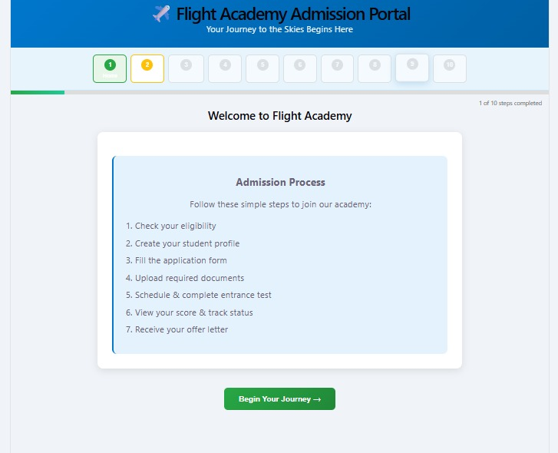
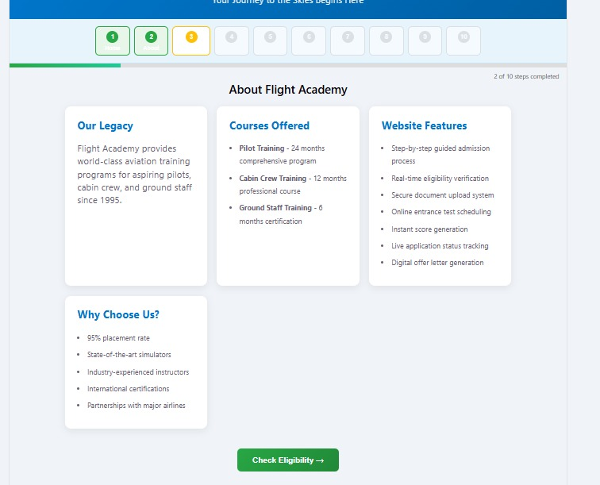
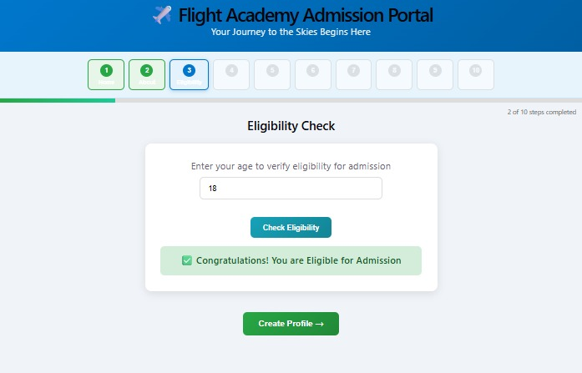

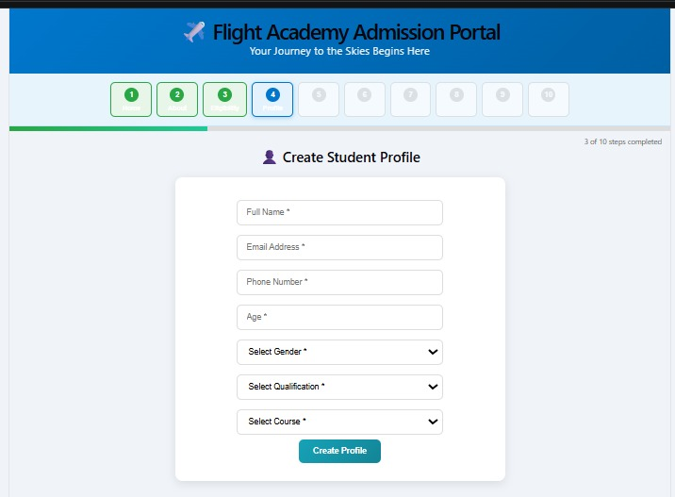
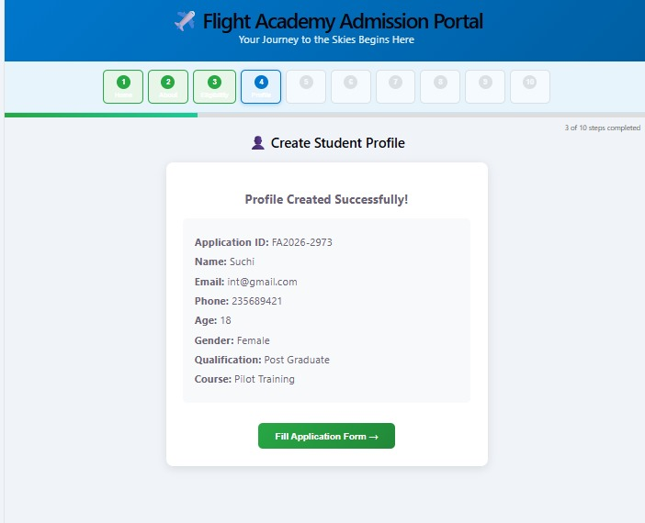

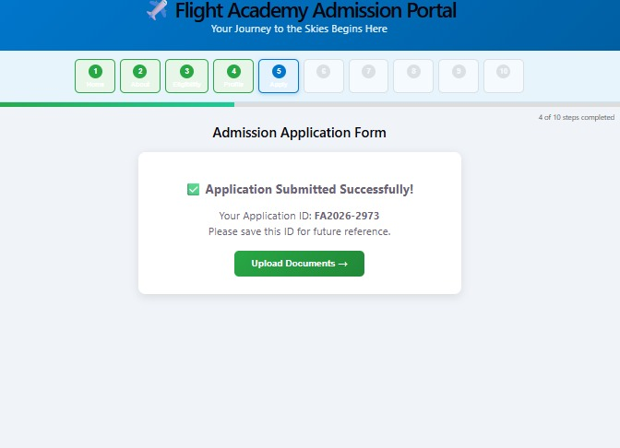
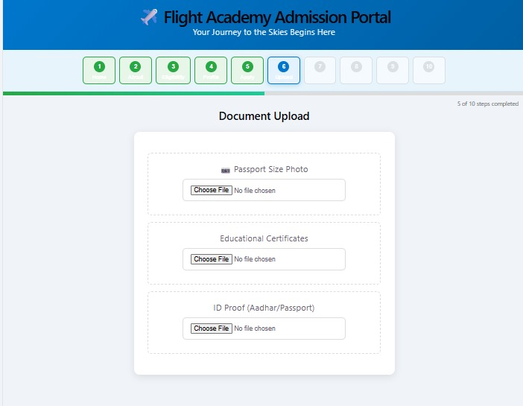

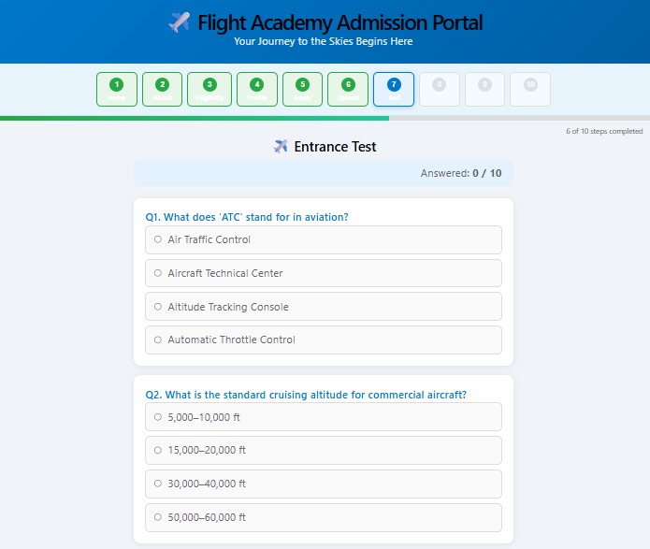

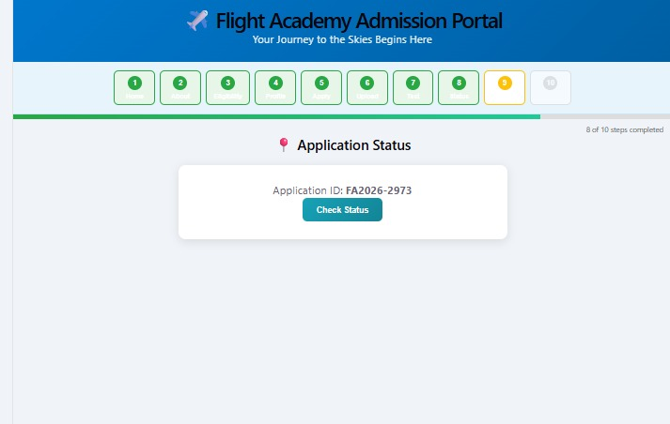
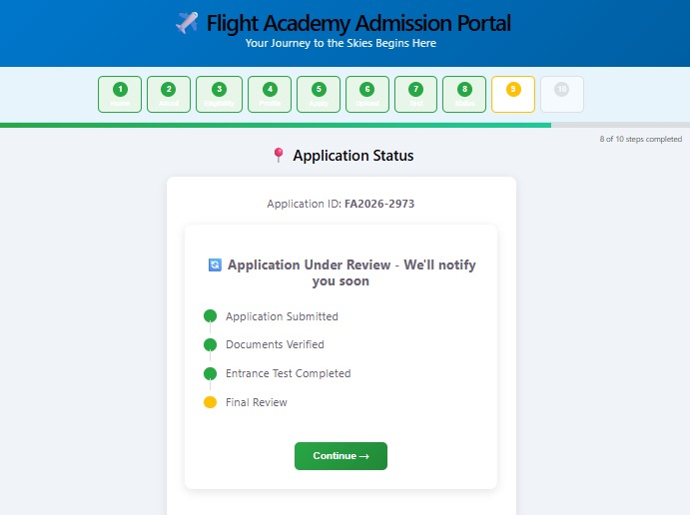
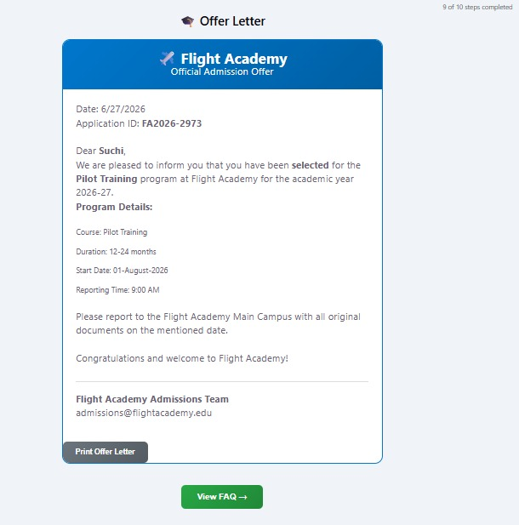
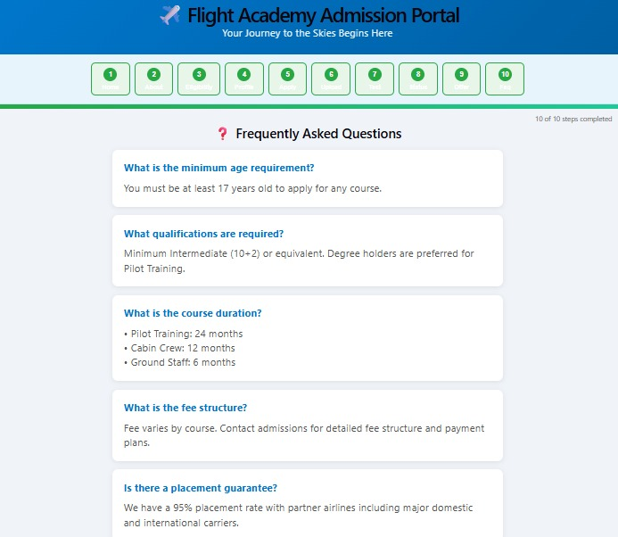

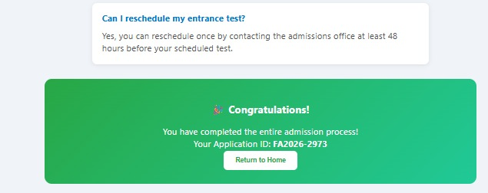

Sample code snippets
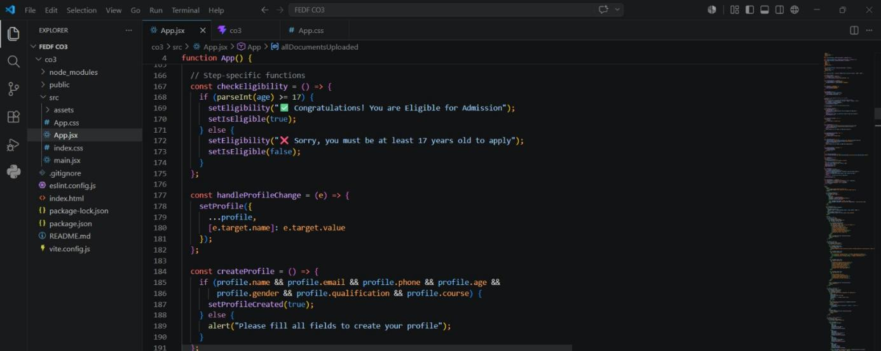
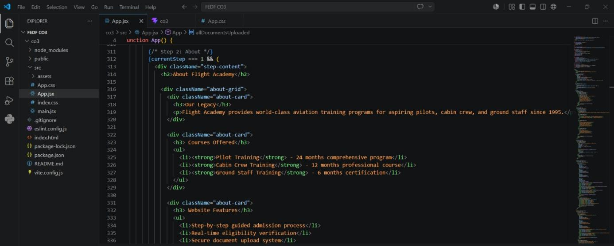

Installation/setup instructions
The GOglobe Integrated Tourism Platform is designed as a lightweight web application developed using HTML5, CSS3, and JavaScript. Since the platform is entirely client-side, it does not require any server-side installation, external frameworks, or database configuration. The application can be installed and executed quickly on any modern computer system.
To begin, obtain the complete GOglobe project folder from the provided source. If the project is distributed as a compressed ZIP archive, extract the contents using any standard file extraction utility. Ensure that all project files, including index.html, style.css, script.js, images, and other supporting resources, remain in their original directory structure.
Next, open the project folder using a source code editor such as Visual Studio Code, Sublime Text, or any preferred IDE. This enables developers or users to review, edit, and maintain the application source code if necessary.
To execute the application, simply open the index.html file in any modern web browser such as Google Chrome, Microsoft Edge, Mozilla Firefox, or Safari. The application launches immediately without requiring additional software installation, package managers, or internet connectivity.
As the platform is completely self-contained, no dependency installation, server configuration, or database setup is required. The application can also operate in offline mode, making it suitable for academic demonstrations, project evaluations, classroom presentations, and learning purposes.

User Manual
The GOglobe Integrated Tourism Platform provides a simple, intuitive, and user-friendly interface that enables users to explore tourism services efficiently.
Upon launching the application, users are presented with the Home Page, which contains the main navigation menu. The navigation bar provides quick access to various sections such as Home, Login, Register, Flights, Trains, Hotels, Hidden Destinations, Travel Assistance, and Contact.
New users can create an account by selecting the Register option and entering the required details in the registration form. Existing users can access the platform by selecting the Login option and providing their login credentials. After successful authentication, confirmation messages are displayed to indicate successful registration or login.
Users can browse the Flights, Trains, and Hotels sections to view available travel options. The Hidden Destinations module introduces unique and lesser-known tourist locations, encouraging users to discover new travel experiences beyond conventional destinations. Each destination includes descriptive information, attractive images, and travel-related details.
The Travel Assistance section offers additional support services such as medical assistance information, hotel guidance, transportation support, emergency contacts, and travel recommendations. These features demonstrate how an integrated tourism platform can assist travellers throughout their journey.
Navigation within the application is smooth and responsive. Menu buttons automatically navigate users to the corresponding sections without requiring page reloads, providing a seamless browsing experience. Interactive elements, confirmation alerts, and responsive layouts further enhance usability across desktop and mobile devices.
The platform has been developed primarily for educational purposes to demonstrate the implementation of an integrated tourism management system using web technologies. It provides users with a realistic simulation of a modern tourism portal while showcasing concepts such as responsive web design, interactive user interfaces, and integrated travel services.

Geo Tag photos with guide


Review forms with guide signatures

